Westward Expansion Web Quest

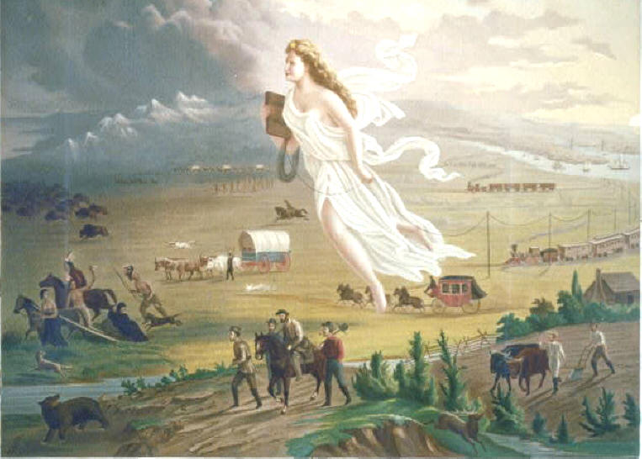
By John Gast (1872)

Directions

Your search for information will lead you to the answers of questions about the growth and change in America from 1800-1861. Get ready to find the answers with the help of the internet sites below.

Take notes and then transfer your work to a Word document. Use complete sentences, or copy and paste the questions into your document so that I know what question you are answering. Notes need to be turned in with your final product. Insert an internet picture to accompany your answers, spell correctly, and use proper writing structure in your final drafts. Cite your graphic resources. Have fun!

List the questions in order and use the internet links above the questions to guide you…
Remember to read through the sites carefully and take notes.
Evaluation

Completed information notes - 20 points
Properly composed Word document – 50 points
Proper Pictures/Graphs/Artwork (At least 10)- 20 points
On task in class – 10 points

Quest Questions

http://members.tripod.com/~jtlawson/index.html

- Who played key roles in the transaction of the Louisiana Purchase?
- Why was the purchase so important?
- Who did Jefferson send to explore the territory?

http://www.semtribe.com/history/BriefSummary.aspx and
http://www.flheritage.com/facts/history/seminole/

- What does the name Seminole mean?
- After the Indian Removal Act of 1830, what did the Seminoles do and have done to them?
- What did the Indian Claims Commission do for the Seminoles in 1970?

http://www.pbs.org/kera/usmexicanwar/war/wars_end_guadalupe.html

- How did the United States approach the negotiations with Mexico?
- How does this treaty continue to affect the United States and Mexico today?

http://www.blm.gov/or/oregontrail/history-faqs.php

- How many miles was the trail and how many months did it typically take to travel it?
- How many pioneers used the Oregon Trail?
- What was the Donation Land Act of 1850?
- What were two main causes of death along the trail?

http://www.historicoregoncity.org/index.php/widgetkit/oregon-trail-history/item/trading-posts-and-forts?category_id=6

- What were two purposes for the forts on the Oregon Trail?

http://www.ourdocuments.gov/doc.php?flash=true&doc=23

- What was the Monroe Doctrine?
- When was the Monroe Doctrine?
- What did the Monroe Doctrine state to European powers?
- What were some lasting effects of this Doctrine?

http://www.history.com/topics/inventions/cotton-gin-and-eli-whitney

- Who invented the Cotton Gin?
- How does the Cotton Gin work?
- Explain the advantages of the Cotton Gin?
- How did the invention help the South to prosper?

http://web.mit.edu/invent/iow/mccormick.html

- What Virginian invented the reaper?
- When was it invented?
- How was it helpful to farmers?

http://www.eyewitnesstohistory.com/fulton.htm

- What impact did Fulton’s improved steamboat have on transportation in the United States?

http://www.uprr.com/aboutup/history/hist-ov/hist-ov2.shtml

- What four things did the transcontinental railroad do for the country?

USE YOUR TEXTBOOK FOR THE FOLLOWING!

- What groups of people joined in the gold rush?
- Where was the gold found?
- What happened to the miners and towns when the gold ran out?
- How was gold discovered in California and who discovered it?

Respond to these Questions, Using The Information Found Throughout This Webquest:

- If you were on the Trail in 1850, what seven supplies would you have taken with you? Why did you choose those seven?
- What new technology was spawned by Westward Expansion?
- What impact did Westward Expansion have on the environment?
- What groups of people moved west and when did they go?

