

Skyward 101 Essentials

Attendance-

You can take attendance through **Post Daily Attendance** by using either **Take Daily Attendance-By Name** or the **Take Daily Attendance-By Seating Chart**. You can also take attendance by going to the Attendance tab in the Gradebook.

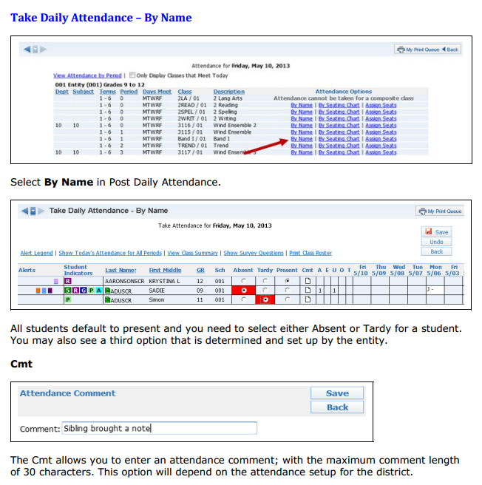

**Note Teachers can view **Alert legend** that will show if students fall under different categories. They can also use different options to change the view and view additional information.

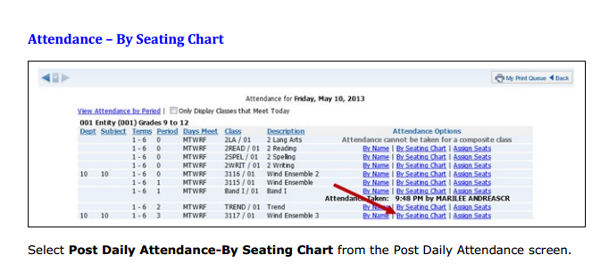

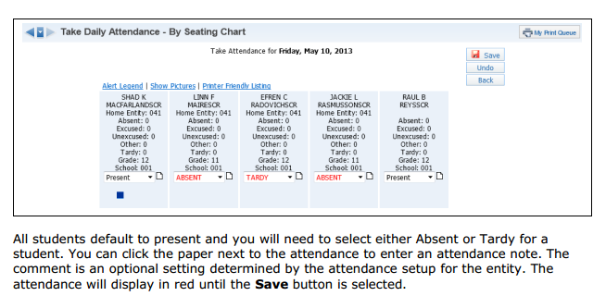

**Note Teachers can view **Alert legend** that will show if students fall under different categories. They can also show pictures if they are loaded and print out a seating chart if they would like (seating chart setup is on previous page)

Student Info + Discipline

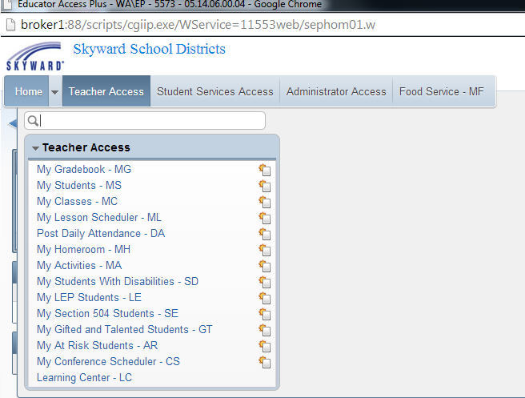

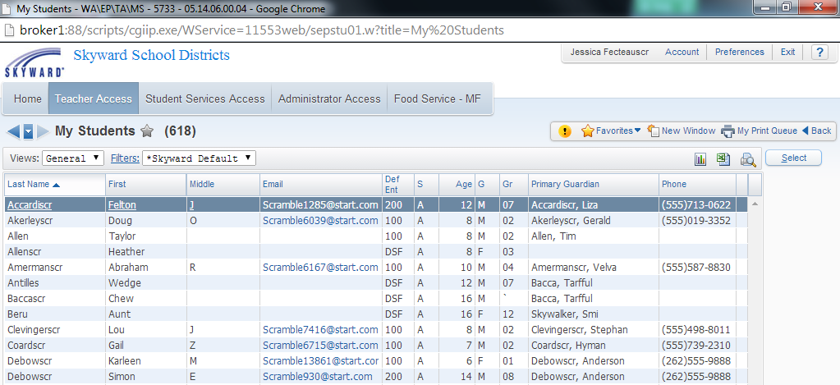

After clicking on **My Students**, you will see a list of students **currently enrolled** in one of your classes. You will highlight the student for whom you want to view information and click on **Select.**

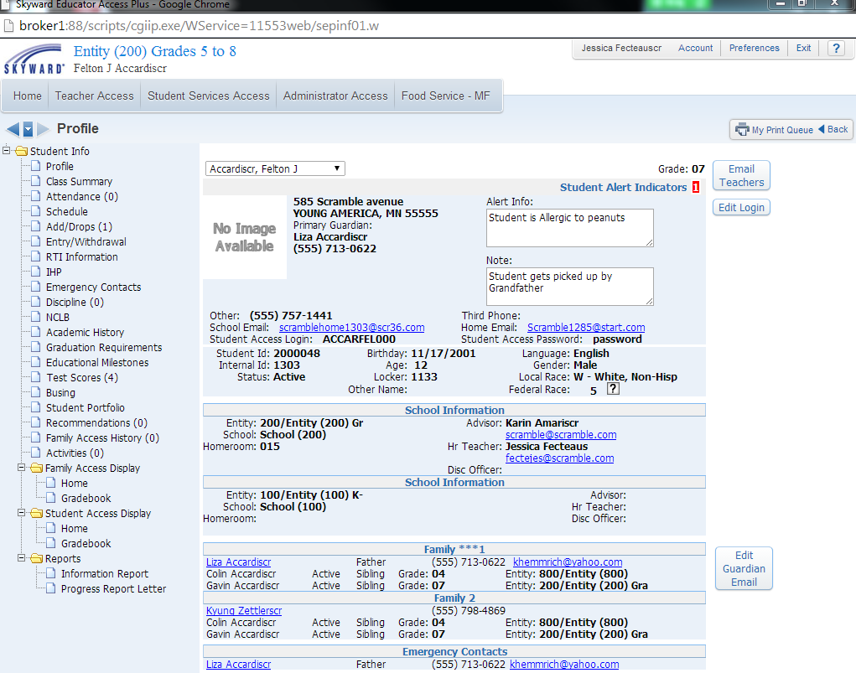

The **student’s info** will load and teachers can now choose options to the left in order to view different student information (some things could be different due to configuration). **Profile** page will show student demographics as well as emergency contacts.

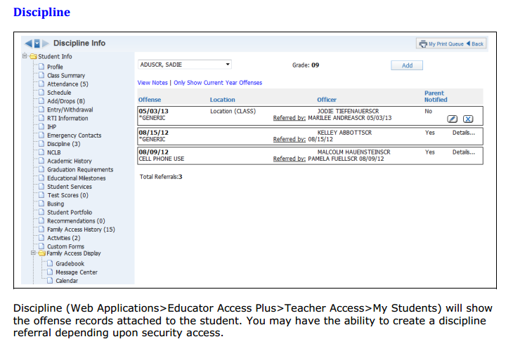

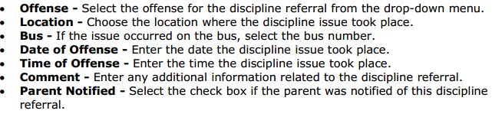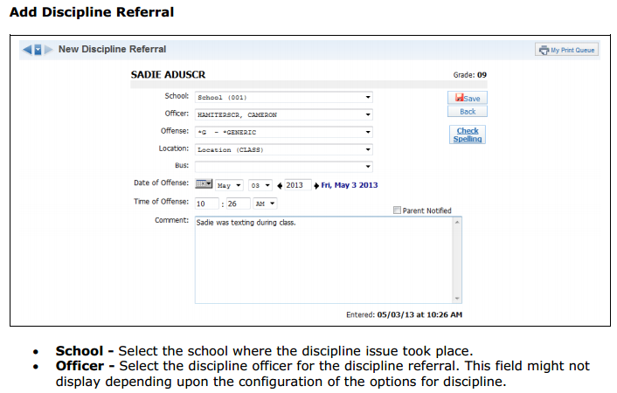

** Note other areas in the Student’s Info including Discipline tab may be different because of configuration.

Gradebook

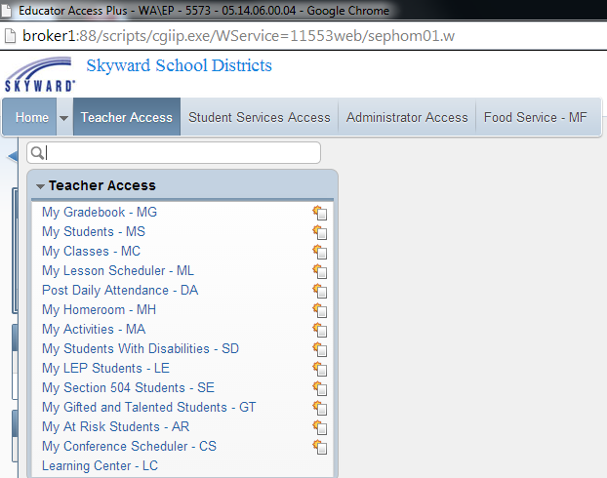

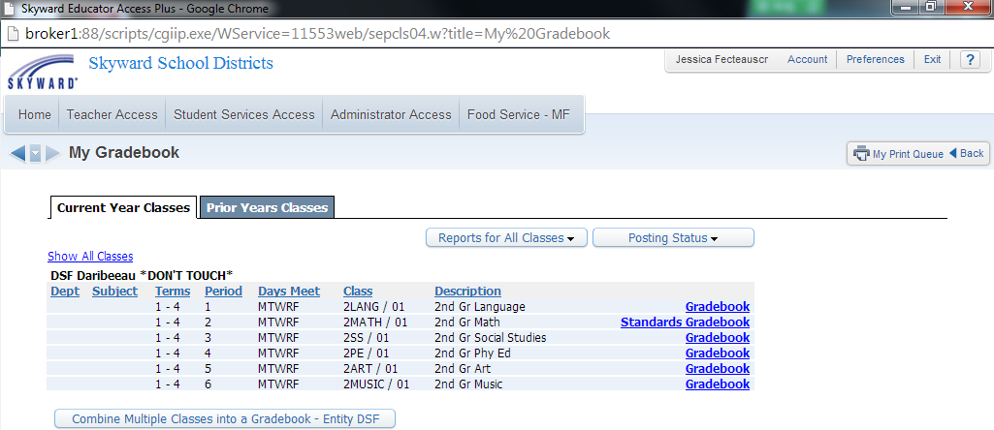

This is the **My Gradebook** screen. From this screen, you are able to access all of your **current classes’** Gradebooks along with those from any past years during which you used the skyward software. Classes will be grouped together based on the entity in which they are taught, so if you teach in multiple entities, your classes will be split into groups.

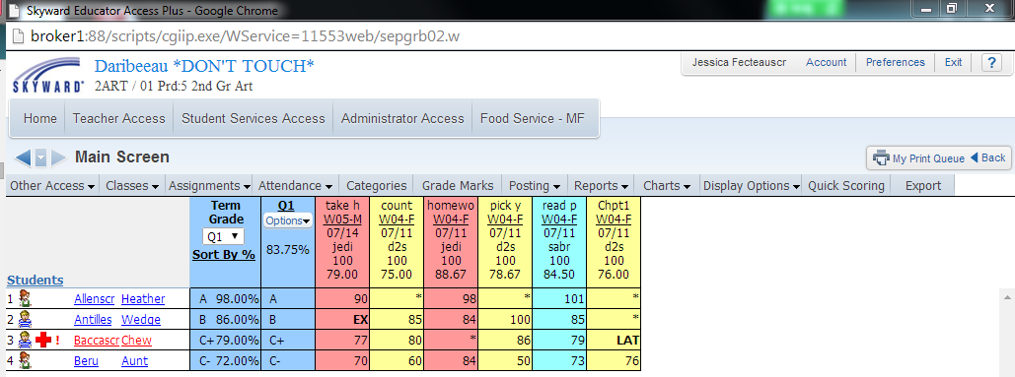

This screen is the Gradebook Main screen. From here, you can see the students in the class, and the assignments and grades. You can maintain the assignments and grades as well. You can also set up the Gradebook, run reports, and enter attendance for the day.

Categories



The **Categories tab** is used as a reference to view the categories that are set up for the class. The Categories and, possibly, their weights are set up by the system administrator. If the district allows you to update the Categories for the class, you will be able to indicate the Categories you want to use and assign percentages to them.

**Categories** are a way of grouping related assignments (for example, Quiz, Homework, Test, and so on). Since Categories are **color coded**, it is easy to identify assignments on the Gradebook Main screen. Additionally, if desired, Gradebook assignments can be sorted by Category so that similar assignment types will be grouped together. Reports can be run to show student performance by Category to assist in identifying areas of strength and weakness. Categories also allow you to assign weighted values if you wish to dedicate a portion of the final grade to specific types of tasks. Categories are used during the addition of new assignments, in the Gradebook display, and in reports

**Note if the district is allowing teachers to choose if they want to base grades on **total points** or **category weighting** teachers **MUST** do this prior to entering in assignments. Teachers may also have the choice of what categories they will be able to choose from depending on configurations.

Assignments

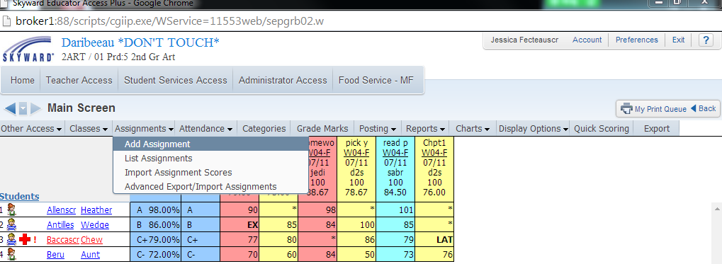

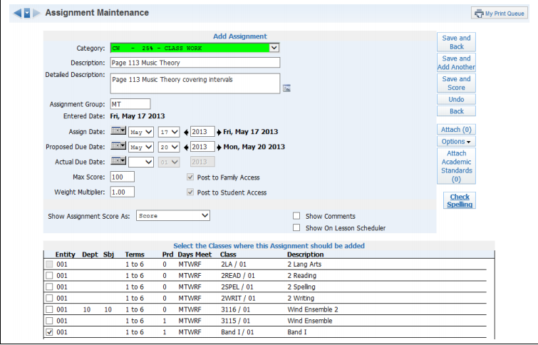

**Category**: Select a category code from the drop-down menu. Note: The Assignment category codes are maintained by administrators.

**Description**: Enter the description of the assignment (maximum of 30 characters). Example: Chapter 1 Test, Worksheet 1B.

**Detailed Description**: Enter a detailed explanation of the assignment (maximum of 300 characters). The Detailed Description can be viewed within Family and Student Access. Click the icon to access a larger window for descriptive details. Example: Chapter 1 Test covering equations.

**Assign Date**: Enter the date the assignment was given to the students; it defaults to the current date.

**Proposed Due Date**: Enter the date you anticipate that the assignment will be due. You can enter future Assign and Proposed Dates; this allows the assignment to display as a future assignment in Family and Student Access.

**Actual Due Date**: Date entered for assignment receiving an extension. An example of when you would enter an Actual Due Date is when you had an inclement weather day or just did not get to the assignment on the proposed due date. The actual due date will supersede the proposed due date.

Scoring Assignment



Click on either the * or the number in the score cell.

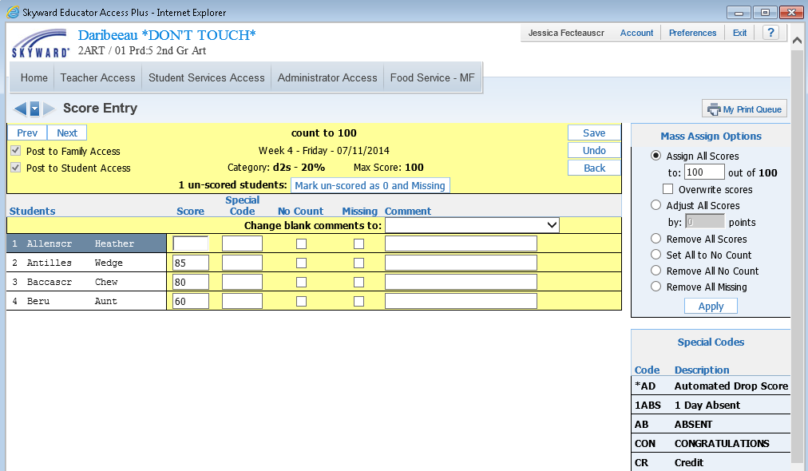

Enter in **score, special codes, no count and/or missing.** May also use mass assign options to the right. Must make sure to hit **save.**