Positive Behavior Support at
McAdoo-Kelayres Elementary School

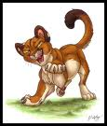

PRIDE produces the following outcomes:

A school-wide positive behavior program that teaches pride, respect, safety, and responsibility

PRIDE
Increased engaged learning time for students

Unity in our school community

Positive Behavior Support at
McAdoo-Kelayres Elementary School

P ROUD to be me
(Liking and Caring about yourself )
R ESPECT for others
(Treating others how I want to be treated )
I will be READY
(Having what I need, being on time )
D o the SAFE thing
(Free from danger, harm or injury)
E veryone shows PRIDE!

PRIDE IN THE CLASSROOM

I will stay in my own space and keep my hands and feet to myself.

Space – Any place the teacher asks me
to be at anytime during the day

I will use kind words and tell the truth.

Truth - What really happened or is
happening (honesty)

I will respect school property and the property of others.

Property – Any item that belongs to
someone or belongs to the school

I will complete my school work and my homework.
School work - Work done in school
Homework - Work assigned by the teacher for me to do at home

I will raise my hand to speak and wait to be called upon.
Speak - To talk
I will use my materials appropriately.
Materials - Any item in the classroom that I use
Appropriately - Correctly

This is a universal (school-wide) rule
PRIDE IN THE CAFETERIA
I will stay in my own space and keep my hands and feet to myself.

I will use kind words and tell the truth.

I will respect school property and the property of others.

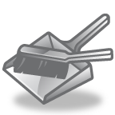I will keep my area clean.
I will walk at all times.

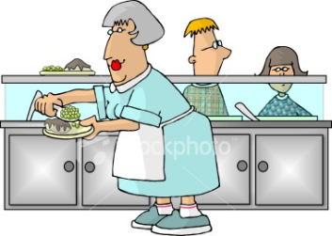I will respect the adults in charge.

Space – Any place the teacher asks the child to be at anytime during the day
Truth - What really happened or is happening (honesty)
Property – Any item that belongs to
someone or belongs to the school
Area – The place around me
Walk – Moving slowly and not running, keeping my hands at my side
Respect – To treat others how you would want to be treated

This is a universal (school-wide) rule

PRIDE IN THE HALL AND STAIRS
I will stay in my own space and keep my hands and feet to myself.

I will use kind words and tell the truth.

I will respect school property and the property of others.

I will always walk in a single file line with my hands at my side.
I will be SILENT in the halls.

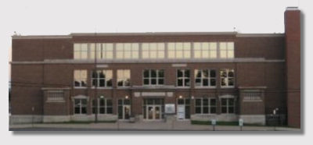I will NOT open the outside door for ANYONE at ANYTIME.

Space – Any place the teacher asks the child to be at anytime during the day
Truth - What really happened or is
happening (honesty)
.
Property - Any item that belongs to
someone or belongs to the school
Single file – Walking behind the person in front of me
Silent – Not talking
Anyone – Any person at all (a teacher, a parent, a student)

This is a universal (school-wide) rule
PRIDE IN THE RESTROOM

I will stay in my own space and keep my hands and feet to myself.
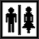
I will use kind words and tell the truth.

I will respect school property and the property of others.

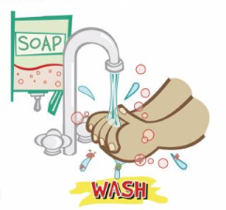I will wash my hands.

I will use a quiet voice in the restroom.

Space – Any place the teacher asks the child to be at anytime during the day
Truth - What really happened or is
happening (honesty)

Property - Any item that belongs to
someone or belongs to the school
Wash – To clean your hands with soap and water
Quiet – Soft (inside voice)

This is a universal (school-wide) rule

PRIDE ON THE BUS / DISMISSAL

I will stay in my own space and keep my hands and feet to myself.
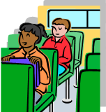

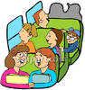I will use kind words and tell the truth.

I will respect school property and the property of others.

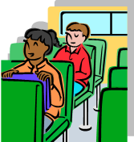I will sit in my seat at all times.
I will not stand while the bus is moving.

I will listen to the bus driver.

At dismissal, I will listen quietly for my bus to be called.

Space – Any place the teacher asks the child to be at anytime during the day
Truth - What really happened or is
happening (honesty)

Property - Any item that belongs to
someone or belongs to the school

Listen – Obey, respect
Bus driver – The man or woman who drives the bus. They are in charge
Dismissal – The time of day when we leave the school
Listen quietly- Paying close attention

This is a universal (school-wide) rule
PRIDE ON THE PLAYGROUND
This is a universal (school-wide) rule

I will stay in my own space and keep my hands and feet to myself.
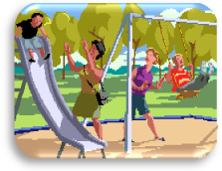

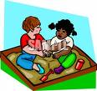I will use kind words and tell the truth.

I will respect school property and the property of others.

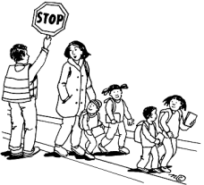I will walk quietly to the playground and use the crosswalk.

I will remain in the playground area.

I will NOT use the monkey bars or see-saw!
I will play fairly and include others in the game!
Space – Any place the teacher asks the child to be at anytime during the day
Truth - What really happened or is
happening (honesty)

Property - Any item that belongs to
someone or belongs to the school

Crosswalk – The area where you cross the street (in between white lines)
Remain – Stay
Monkey Bars – The silver metal bars that children climb
See-saw - teeter-totter
Fairly – Following the rules
Include- Let others play

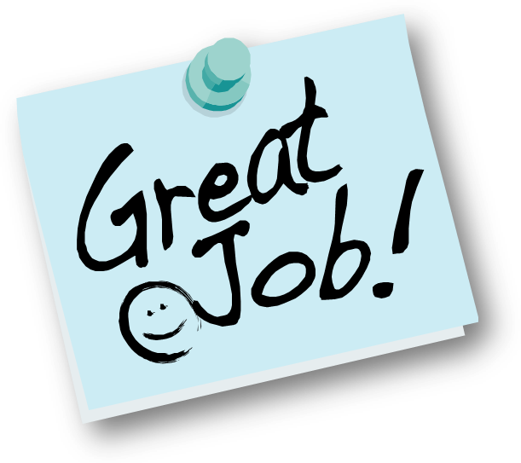

School-Wide Reinforcement Plan
Students can earn a token or paw punch from staff members in the building
by modeling expected positive behaviors.

Cards can be redeemed through classroom store.

Classes earn PRIDE PAW from staff members when caught
modeling expected positive behaviors.

Entire school celebrates as classes reach behavior goals.

Everyone shows PRIDE

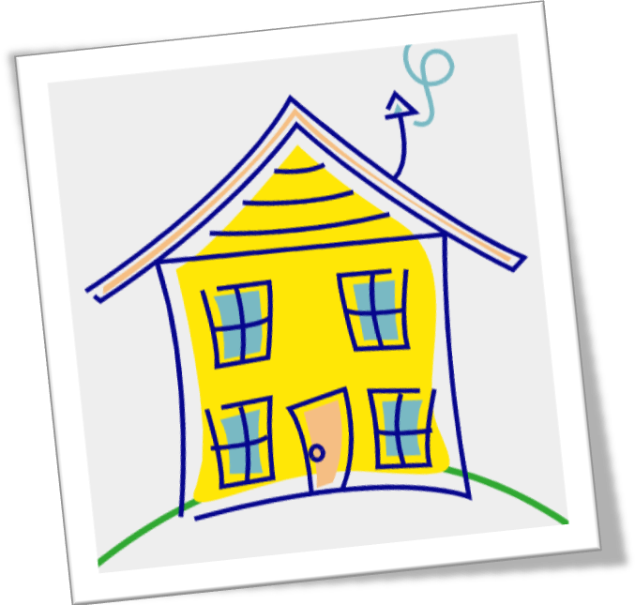

Parents’ Role in PRIDE
Parents know their child’s specific grade level behavior expectations.
Parents sign the PRIDE contract, thereby agreeing to support their child in
meeting behavior expectations.

Parents model and reinforce pride, respect, safety, and responsibility at
home.

Parents participate in celebrating the positive behavior success of their
child.

