PJAS Region Registration 2016-2017
Please read this section before you begin.
- All sponsors will be asked for judging areas. What if you don’t judge at your region meet because you are assigned other tasks? Complete the judging info anyway. Your region staff will handle your special case. .
- What if my school isn’t in the drop down list? Contact your region director* and follow his/her directions.
- What if the Next button at the bottom of some pages is gray and not accessible? This means that you have not completed one of the questions on that page or did not give valid data. Errors will be marked in red. Complete all blanks and/or fix the error and the Next button will work.
- What if you entered incorrect information, had a typo, etc. Keep going and finish. You can use the dashboard to fix/change items. The dashboard is explained toward the end.
- Some regions are collecting clearance information. If you don’t have it when you register, you can log on later and complete the information.
- What if you sponsor students in two or more schools? You will need to create an account for each school with different usernames. You may use the same email for all schools.
Questions should be directed to put name, email, phone here. Also any specifics such as best time. *or allow sponsors to enter the school name.
Go to: www.pjasregistration.com Your screen should look like this:
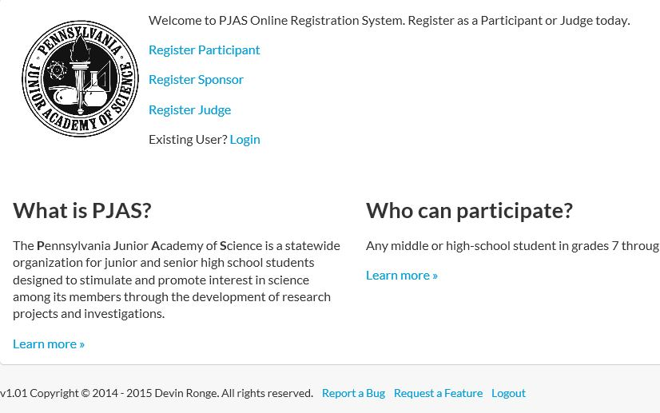
This Logout is at the bottom of all pages. Remember to logout at the end.
After you register, use the login for all future visits
Do not use this. This is for outside judges.
You, the sponsor, use this.
Students use this

Your screen should now look like this. Use the New User? form to create your registration. If you think you won’t remember the information, write it down. For future use, you will use the “Already have an account?” side.

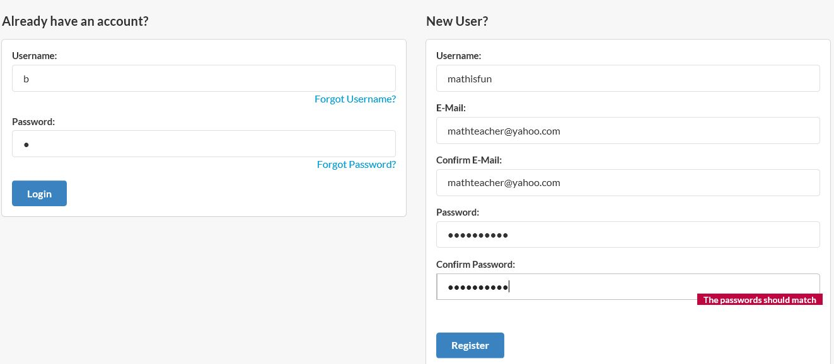
Go ahead and complete the wizard. It is as easy as that.
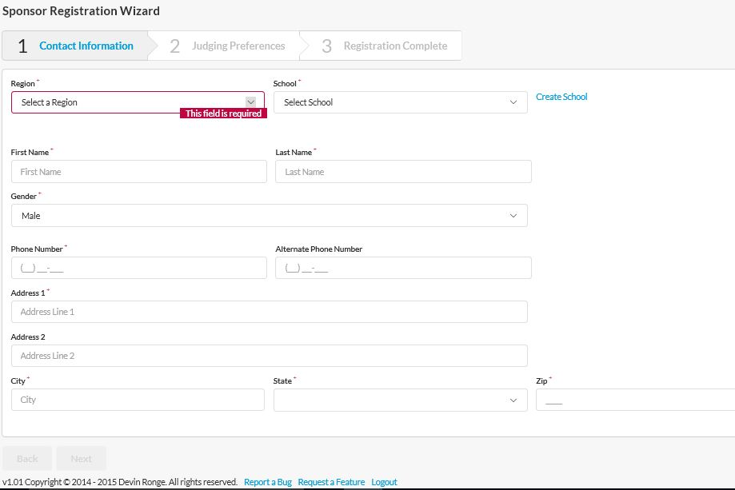
When you click on dashboard you get this:
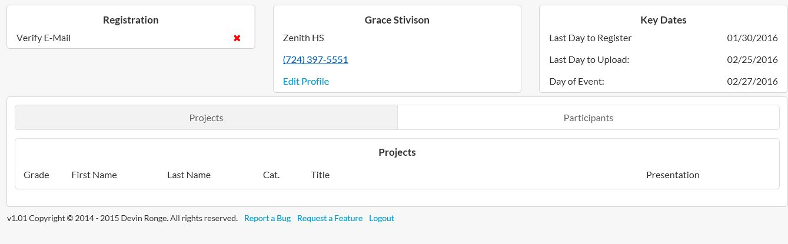

The dashboard is a really nice feature as it gives easy access to all information. If you made a mistake in your personal information, click on edit profile. The area where it says Projects and Participants will show you which students have registered and which have not. Note the red X under registration. The X means the process has not been completed. In this case, you must go to your email, open the email from registration@mailer.pjasregistration.com and confirm your email. You can do it later, when you are checking your email, or do it now. Once you confirm your email, the X will go away. (If you do it immediately, you may have to refresh the screen or possibly log out and then back in for the X to go away.)
Logout at the bottom of the screen. That is all for now. Student registration information will follow.

