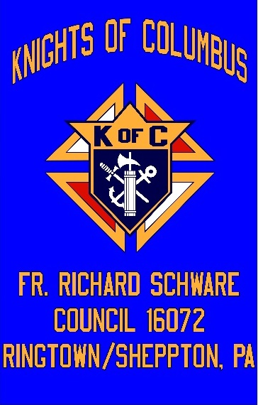

**The FR. Richard Schware**

**Council 16072**

**Knights of Columbus**

**2024 Scholarship**

Eligible applicants must meet the following criteria:

*Applicant must be a current High School Student on track to graduate in 2024.

*Applicant must be a current *active member of St. Mary’s Roman Catholic Church, Ringtown or St. Joseph’s Roman Catholic Church, Sheppton, PA.*

*Attending an institution of higher education in the fall of 2024: two or four-year college

or university, community college, business or trade school. Attendance may be part or

full time.

*Applicants planning to attend a Military Academy are also eligible.

How to Apply: Complete the attached application form and submit the completed application and essay by **May 5th 2024.**

*Completed application and essay should be mailed to:*

*Knights of Columbus Council #16072*

*St. Mary’s Roman Catholic Church*

*82 North Center Street*

*Ringtown, PA 17967*

**Scholarship winners will be contacted directly by the Council.**

**The FR. Richard Schware**

**Council 16072**

**Knights of Columbus**

**2024 Scholarship Application**

**Personal Information**:

Name ________________________________________________________________________

Address ______________________________________________________________________

Phone: _______________________________ E-mail: _________________________________

Name and phone number of Parents/Guardians:

______________________________________________________________________________

***The information on this page is for reference only. Personal information will remain anonymous and will not be reviewed by the scholarship committee in determining scholarship recipients.***

**The FR. Richard Schware**

**Council 16072**

**Knights of Columbus**

**2024 Scholarship Application**



The Knights of Columbus strongly believe in aiding those in need and embrace the importance of charitable works. Knights strive to help the sick, the elderly, the poor, and the disadvantaged. We feel that following this path in our everyday life can truly make a difference in the world.

**ESSAY QUESTION: Answer Part 1 and either (Part 2 or Part 3) of the essay questions in short paragraphs.**

*Part One: Why do you believe it is important to be an active church member?*

*Part Two: Give an example of a selfless act you have experienced or observed and explain the impact it had on you.*

*Part Three: How have you made a difference or how do you plan to make a difference, whether in your community, in your future profession, or beyond?*

**The FR. Richard Schware**

**Council 16072**

**Knights of Columbus**

**2024 Scholarship Application**

**Current Active Member (circle one)**

*St. Mary’s Ringtown PA*

*St. Joseph’s Sheppton PA*

**Education Information:**

Current GPA: ___________________ Current class rank: ___________/__________

Institution(s) of Higher Education you plan on attending or have applied to: ____________________________________________________________________________________________________________________________________________________________

Have you been accepted to any of the above schools? _____________________________________________________________________________

Intended major course of study: ____________________________________________________

**Additional Information (Please answer all questions that apply to you: additional information can be listed on the back of this sheet):**

Parish activities you have participated in: (examples may include activities such as participating in the annual block party and/or serving mass) ______________________________________________________________________________

____________________________________________________________________________________________________________________________________________________________

Additional Community or School activities you have participated in:

______________________________________________________________________________

____________________________________________________________________________________________________________________________________________________________

____________________________________________________________________________________________________________________________________________________________