1. Explain why in this illusion, black spots quickly appear and disappear at the intersections.

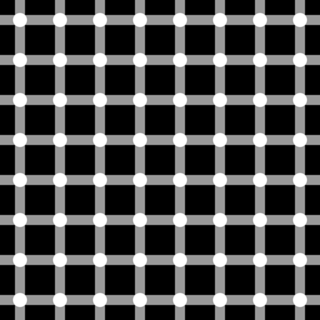

1. Look at the red dot in the middle and move your head towards and away from the screen. See how the outer rings appear to rotate? WHY?

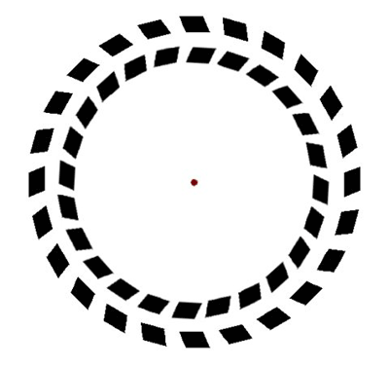

1. How is this spiral formed?

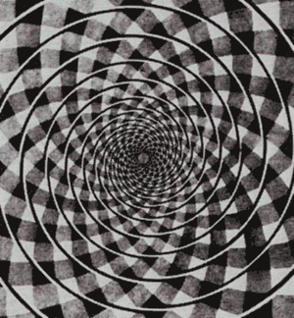

1. What can you see? WHY?

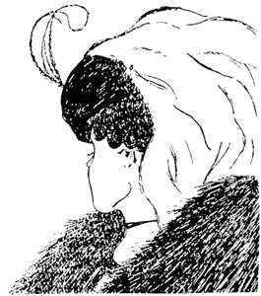

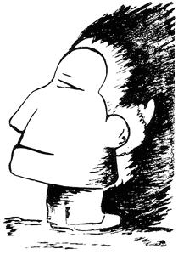

1. What do you see? Why?

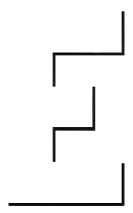

1. Look at the two thick vertical lines. Do they look straight or curved to you? Hold a pencil up to the screen and you will see.

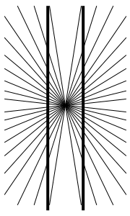

1. What do you see? WHY?

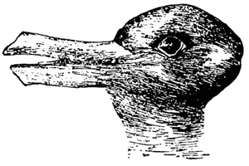

1. Are the horizontal gray lines curvy or straight? Hold up a piece of paper to prove.

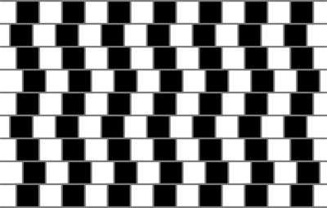

1. How many legs does this elephant have?

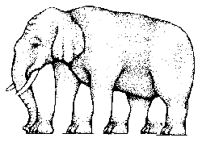

1. Look at the center of the image for about 30 seconds. Then quickly shift your gaze to somewhere with a white background. What happens and why.

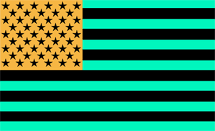

1. T the smaller off-center circle is what shape and why?.

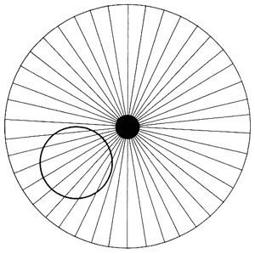

1. Small grey dots should appear at the intersections of the squares, but if you look directly at the intersection, the grey dots will disappear. WHY?

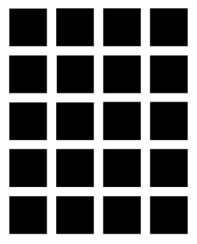

1. Depending on how you look at this image, WHAT DO you see and WHY?.

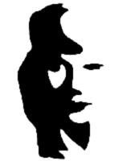

1. Are the holes on the inside or outside?

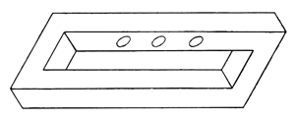

1. Is the square in the middle a perfect square? WHY?  
     
   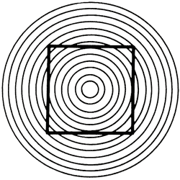
2. [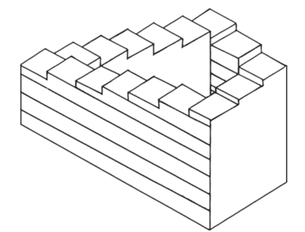](http://www.braingle.com/brainteasers/28483/impossible-stairs.html)

Which way are the steps moving?

1. Which circle is bigger left or right middle?  
   [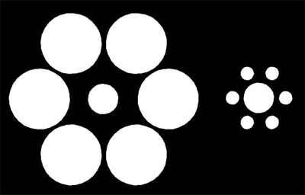](http://www.braingle.com/brainteasers/26475/equal-circles.html)
2. When you move your eyes in a circular motion around this image, you will see what appears to be spokes moving around with your eyes. Why?  
   [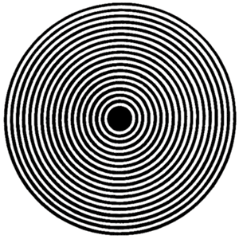](http://www.braingle.com/brainteasers/28482/moving-spokes.html)
3. This object is called a blivet. How many prongs does it have?  
   [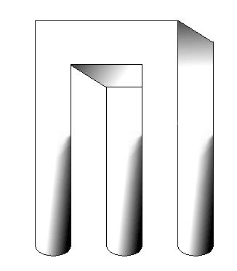](http://www.braingle.com/brainteasers/26473/blivet.html)
4. [What](http://www.braingle.com/brainteasers/26474/face-or-vase.html) do you see?  
   [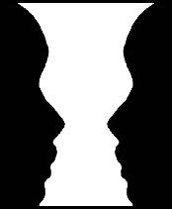](http://www.braingle.com/brainteasers/26474/face-or-vase.html)
5. Is the triangle in three or two dimensions[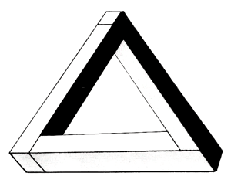](http://www.braingle.com/brainteasers/26962/impossible-triangle.html)
6. Which line (A or B) continues to the other side?[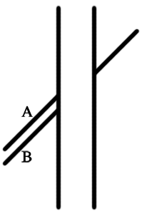](http://www.braingle.com/brainteasers/26964/continued-line.html)
7. [What](http://www.braingle.com/brainteasers/26490/gray-squares.html) color are the squares? Use your fingers or a piece of paper with holes cut in it to block out the rest of the picture and you will see that they are. Why?  
   [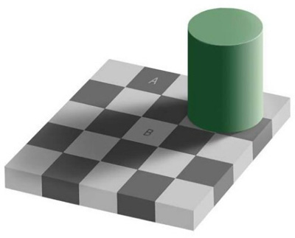](http://www.braingle.com/brainteasers/26490/gray-squares.html)
8. Are the points marked with A and B in front, or in back? Why?  
   [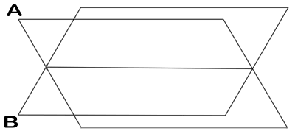](http://www.braingle.com/brainteasers/28639/unstable-fins.html)
9. Look at lines A and B. Which one is bigger?  
   [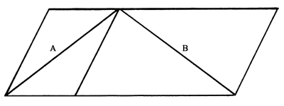](http://www.braingle.com/brainteasers/26768/sandors-parallelogram.html)
10. What do you see and WHY? [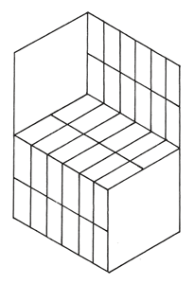](http://www.braingle.com/brainteasers/27109/chair-or-block.html)
11. Which horizontal line is longer?  
    [http://images.braingle.com/images/illusions/30410.gif](http://www.braingle.com/brainteasers/30410/glasses-and-dumbbells.html)
12. Which arc comes from the largest circle? [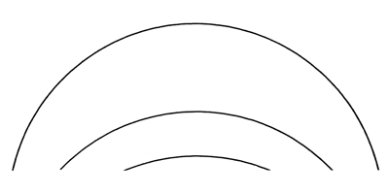](http://www.braingle.com/brainteasers/26767/arcs.html)
13. How many right angles appear in the following image?
14. 