Ventilation and Heart Rate
In this experiment, you will investigate the effect of altering the levels of oxygen and carbon dioxide on the rate at which the heart beats. Two different methods of ventilation will be used to investigate this phenomenon. The first method, hyperventilation, is when the breathing rate of an organism is greater than what is necessary for proper exchange of oxygen and carbon dioxide. This will be achieved by a period of rapid breathing by the test subject. The second method, hypoventilation, occurs when there is a decrease in ventilation without a decrease in oxygen consumption or carbon dioxide production by the body. True hypoventilation is usually the result of a disease. The test subject will simulate this condition by holding his or her breath for a period of time. Heart rate will be monitored using the Exercise Heart Rate Monitor.

OBJECTIVES
In this experiment, you will
- Monitor the heart rate of the test subject using a Heart Rate Monitor.
- Evaluate the effects of hyperventilation and hypoventilation on heart rate.

MATERIALS
LabQuest | dropper bottle with saline solution
LabQuest App | (only for use with the Exercise HRM)
Vernier Hand-Grip Heart Rate Monitor or
Vernier Exercise Heart Rate Monitor

PROCEDURE
Each person in a lab group will take turns being the subject and the tester. When it is your turn to be the subject, your partner will be responsible for recording the data on your lab sheet.
1. Connect the receiver module of the Heart Rate Monitor to LabQuest and choose New from the File menu. If you have an older sensor that does not auto-ID, manually set up the sensor.
2. On the Meter screen, tap Length. Change the data-collection length to 120 seconds.
3. Set up the Heart Rate Monitor. Follow the directions for your type of Heart Rate Monitor.
Using a Hand-Grip Heart Rate Monitor
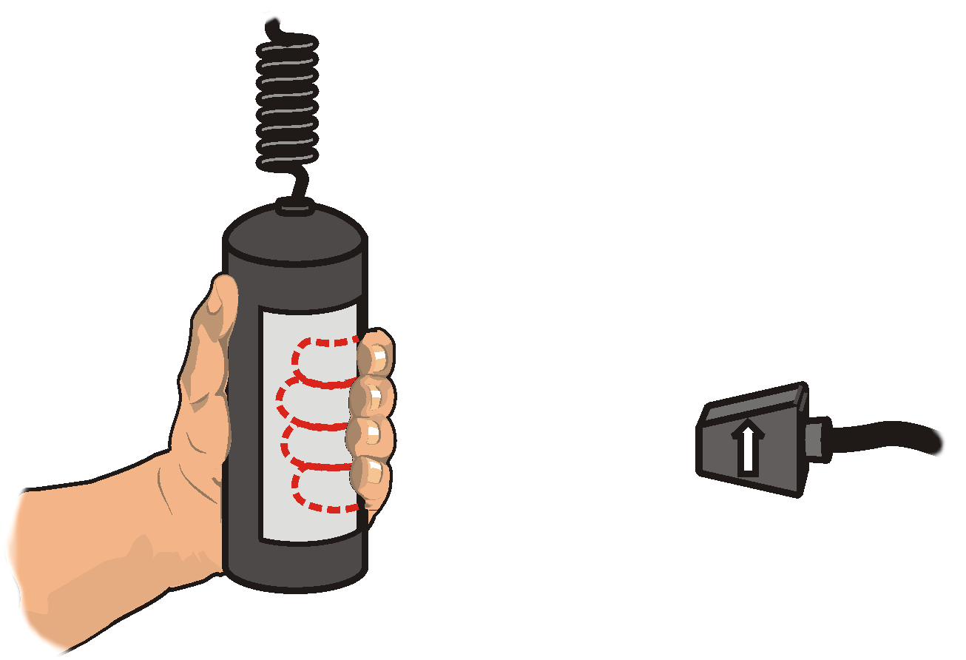
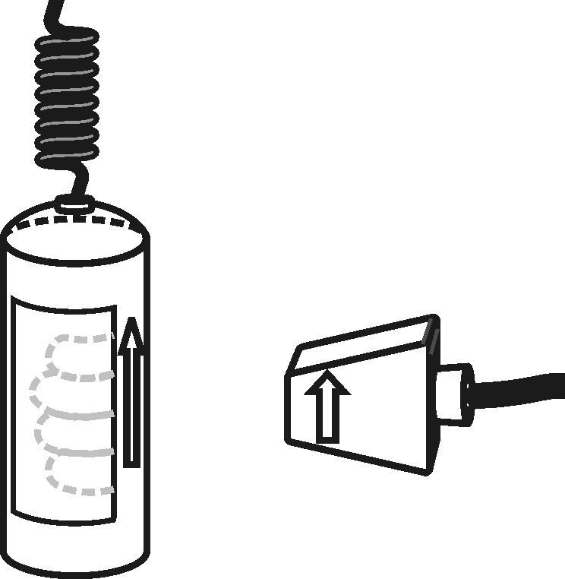
- Grasp the handles of the Hand-Grip Heart Rate Monitor. Place the fingertips of each hand on the reference areas of the handles (see Figure 1).
Figure 1
- The left hand grip and the receiver are both marked with an alignment arrow. When collecting data, be sure that the arrow labels on each of these devices are in alignment (see Figure 2) and that they are not too far apart. The reception range of the plug-in receiver is 80–100 cm, or 3 feet.
Figure 2
Using an Exercise Heart Rate Monitor
Figure 3
- Depending upon your size, select a small- or large-size elastic strap. Secure one of the plastic ends of the elastic strap to the transmitter belt. It is important that the strap provide a snug fit of the transmitter belt.
- Wet each of the electrodes (the two textured oval areas on the underside of the transmitter belt) with 3 drops of saline solution.
- Secure the transmitter belt against the skin directly over the base of the rib cage (see Figure 3). The POLAR logo on the front of the belt should be centered. Adjust the elastic strap to ensure a tight fit.
- Take the receiver module of the Heart Rate Monitor in your right hand. Remember that the receiver must be within 80 cm of the transmitter in the Heart Rate Monitor belt.

4. Start data collection. Determine that the sensor is functioning correctly. The readings should be consistent and within the normal range of the individual, usually between 55 and 80 beats per minute. When you have determined that the equipment is operating properly, stop data collection and proceed to Step 5.
Part I Hyperventilation
5. Collect data while the subject hyperventilates.
- Instruct the subject to sit still in a chair and breathe normally.
- Start data collection. After collecting data for 30 seconds, have the subject make rapid shallow breaths for the next 30 seconds.
- The subject should then breathe normally for the remaining 60 seconds.

6. When data collection is complete, a graph of heart rate vs. time will be displayed. To examine the data pairs on the displayed graph, tap any data point. As you tap each data point, the heart rate values of each data point are displayed to the right of the graph.
7. Record the heart rate in Table 1 for every 10 second interval.
8. Store the data from the first run by tapping the File Cabinet icon.
Part II Hypoventilation (simulated)
9. Collect data while the subject hypoventilates.
- Instruct the subject to sit still in a chair and breathe normally.
- Start data collection. After collecting data for 30 seconds, have the subject take a large breath and hold it as long as possible. The subject should not hold his or her breath longer than 60 seconds.
- The subject should breathe normally for the remainder of data collection.
10. When data collection has finished, a graph of heart rate vs. time will be displayed. To examine the data pairs on the displayed graph, tap any data point. As you tap each data point, the heart rate values of each data point are displayed to the right of the graph.
11. Record the heart rate in Table 1 for every 10 second interval.
12. Graph both runs of data on a single graph. To do this, tap Run 2 and select All Runs.
13. (optional) Print a graph of heart rate vs. time (with two curves displayed). Label each curve as “hyperventilation or “hypoventilation”.

DATA
Table 1
Time (s) | 10 | 20 | 30 | 40 | 50 | 60 | 70 | 80 | 90 | 100 | 110 | 120
Hyperventilation
Hypoventilation

QUESTIONS
1. What happens to the heart rate during hyperventilation?
2. What happens to the heart rate during hypoventilation?
3. List several factors that you think may have caused the test subject’s heart rate to change in each of the trials.
4. What happens to the oxygen levels in your lungs during hyperventilation? Carbon dioxide levels?
5. In what way would the change in heart rate that corresponds with holding your breath be advantageous in other types of organisms? What organisms might commonly exhibit such an adaptation?

