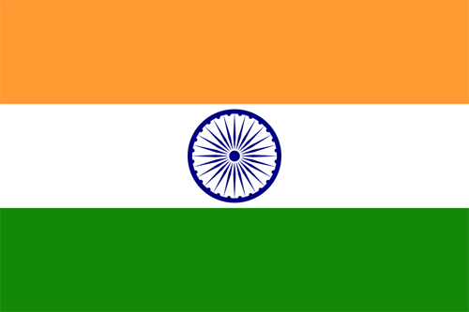
- Of what country was India a colony? What sort of aid did India give to the Allied forces? What two religions were most important in India? Which was the majority? The minority?

- In which city & when did British troops fire into a trapped crowd of Indians? What were the Indians doing there? About how many people were killed/injured?

- Who became the leading Indian nationalist? What were his feelings towards violence in disputes? What were his protest methods based on?

- What was one form of protest Indians found effective? What did this form of protest do in regards to cloth? What became the symbol of the National Congress?

- What did the above form of protest do in regards to salt? What did Gandhi do/where did he go to deal with this issue?

- What did the British Parliament pass in 1935? What did this give to Indians? What areas were affected? Did every Indian like this act?

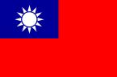

- Who and when was China declared a republic? How did this government change to another form? When was a republic finally established? What did the government do?

- What two groups both disliked the warlords that ruled for a time? Did these two groups like each other?

- What was the Red Army? Where did they form? Who led them? What group of people did the leader appeal to for help?

- How was life for China’s peasants? What did the Red Army do for them? How did the Red Army fight their enemies?

- What was the Long March? When was it? Who and how many people participated?

- How long was the “Long March”? About how many miles were covered in a day? What obstacles did the people overcome?

- What role did Japan play in China during the 1930s? What area had Japan conquered? By 1939, about how much of China was controlled by Japan?

