**Matter & States of Matter**

**- Matter:**

- matter – anything that takes up space and has mass

- mass – a measure of how much matter is in a particular substance

- substance – a material with a definite chemical composition

- atom – the smallest part of a substance that still retains the properties of

that substance

- **Properties of Matter:**

- physical property – can be observed WITHOUT changing the identity of

the substance

1) color 6) solubility

2) odor 7) melting point

3) hardness 8) boiling point

4) density 9) temperature

5) mass 10) luster

- physical properties could be:

1) INTENSIVE – does NOT depend on the amount of the

substance

2) EXTENSIVE – DOES depend on the amount of the substance

- chemical property – can be observed ONLY by changing the identity of

the substance

1) burnable/flammable 5) ability/tendency to rot

2) tendency to rust 6) corrosive

3) ability/tendency to decompose 7) ability to ferment

4) explosiveness 8) combustible

- there are 2 types of properties (PHYSICAL and CHEMICAL)

- chemical properties involve a change of identity (physical does NOT)

- **Changes in Matter:**

- a CHANGE refers to a change in a property of a substance

- if this change involves a change of identity it is chemical (if NOT it is

physical)

- physical change – alters a material WITHOUT changing it’s identity

1) boiling 6) splitting

2) freezing 7) cutting/breaking/bending

3) dissolving 8) crushing

4) melting 9) cracking

5) condensing 10) grinding

- chemical change – alters a material along with a CHANGE of identity

- another name for a chemical change is a chemical reaction

1) burning 5) rotting

2) rusting 6) corroding

3) decomposing 7) fermenting

4) exploding 8) combusting

- properties are descriptive (adjectives and adverbs)

- changes are action (verbs)

- **Classifying Matter:**

- matter can be classified as:

1) PURE SUBSTANCE – has a definite composition that is the SAME

throughout

A. **ELEMENTS** – simplest forms of matter that still retain the

properties of that matter

- CANNOT be separated into simpler substances by

ordinary chemical means

- elements are the building blocks of compounds

B. **COMPOUNDS** – substances that CAN be separated into

simpler substances only by chemical means

- compounds are 2 or more elements chemically

combined

- properties of a compound are different from the

elements that make it up

2) MIXTURE – a physical blend of two or more substances

A. **HOMOGENEOUS** – the SAME composition throughout the

entire mixture

- one part is exactly like any other part

- ALL solutions are homogeneous!!

B. **HETEROGENEOUS** – has a DIFFERENT composition from one

part of the mixture to another

- mixtures CAN be separated by PHYSICAL means!!

- distillation – the process by which water is purified by boiling

and condensing back to a liquid

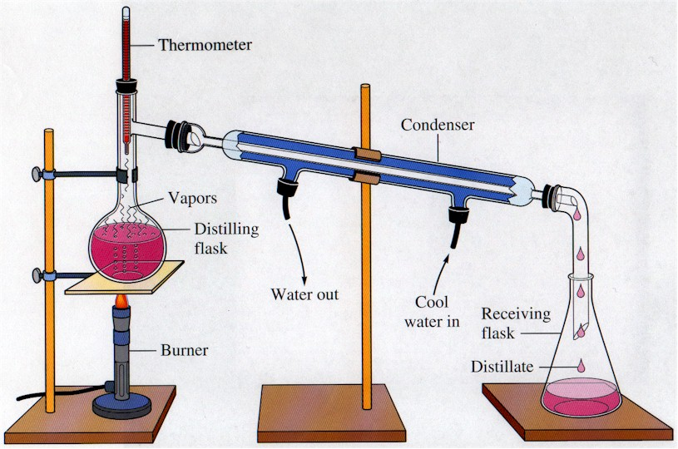

Image courtesy of <http://blogofchemistry.blogspot.com/>

**- States of Matter:**

1) SOLID – has a definite shape and definite volume

- particles of matter are tightly packed together and not moving

(not changing locations)

- associated with LOW relative temperature

2) LIQUID – has a definite volume but takes the shape of its container (no

definite shape)

- particles of matter are close together but FLOW past each other

(change their location)

- associated with MEDIUM relative temperature

3) GAS – no definite shape and no definite volume

- particles of matter are far apart from each other

- constantly moving

- associated with a HIGH relative temperature

- vapor – gaseous state of a substance that is normally a liquid or

solid at room temperature

4) PLASMA – similar to a gas but the particles are separated (bonds are

broken holding molecules together) and ionized (becomes charged ions

with (+) and (-) charges)

- usually associated with extremely high temperatures

- ex. The sun and lightning

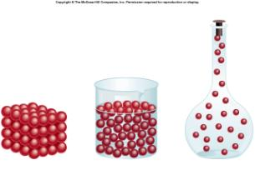

Image courtesy of <http://5alanguagearts200910.wikispaces.com/Solids,+Liquids+%26+Gases+1>

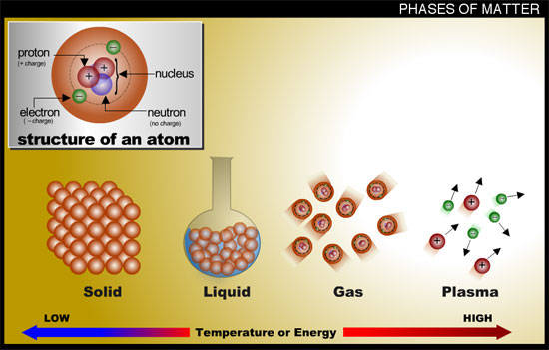

Image courtesy of <http://www.tech-faq.com/what-are-the-five-states-of-matter.html>

- **Symbols, Formulas & Reactions:**

- chemical symbol – one or two letter abbreviation for an element

- 1st letter is always CAPITALIZED!!

- 2nd letter (if there is one) is always lowercase!!

- chemical formula – represents different elements as symbols and the

number of each as a subscript FOLLOWING the symbol

- Ex.: H2O, C12H22O11, NaCl, CaBr2

- chemical reaction – occurs when one or more substances undergo a

change into new substances

- REACTANTS – starting materials (undergo the change)

- PRODUCTS – new substances that are formed

- reactants are always written on the left side, products on the right

and separated by an “🡪”

- Indicators of a Chemical Reaction Taking Place:

1) heat absorbed or given off (temperature change)

2) change in color

3) odor of a gas given off (or presence of bubbles in solution)

4) formation of a precipitate in solutions

- **Law of Conservation of Matter (Mass):**

- Law of Conservation of Matter – *Matter (or mass) cannot be created or*

*destroyed in any chemical or physical change*

- discovered by Antoine Lavoisier

- the TOTAL mass of the reactants must EQUAL the TOTAL mass of the

products

- you can’t create anything, you don’t destroy anything

- in a chemical reaction, bonds are broken, then matter is REARRANGED,

then bonds are reformed!!!

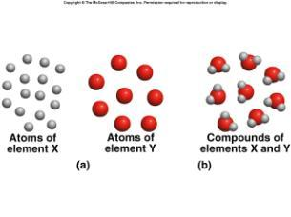

Image courtesy of <http://martine.people.cofc.edu/111LectWeek1.htm>

- **Energy and Changes In Matter:**

- energy may be RELEASED or ABSORBED during chemical and physical

changes

- EXOTHERMIC – a process that RELEASES heat energy

- heat is written as a PRODUCT

- 2 H2 + O2 🡪 2 H2O + heat

- H2O(l) 🡪 H2O(s) + heat

- ENDOTHERMIC – process that ABSORBS heat

- heat is written as a REACTANT

- CaCO3 + heat 🡪 CaO + CO2

- H2O(s) + heat 🡪 H2O(l)

[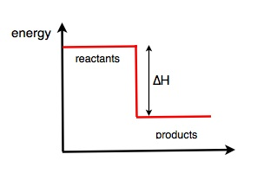](http://wikieducator.org/images/1/13/Exothermic.jpg)[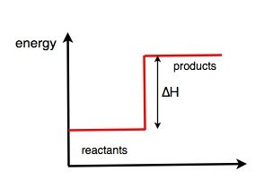](http://wikieducator.org/images/0/0c/Endothermic.jpg)

EXOTHERMIC ENDOTHERMIC

(heat released) (heat absorbed)

Images courtesy of Wikipedia <http://wikieducator.org/201_Chemistry/2.6>