**EUROPEAN THEATER MAP ASSIGNMENT**

**(40 pts.)**

Use the map on pg. 470 of the textbook to complete the map

Label the following countries on the map of Europe:

1. Germany 12. Hungary
2. Italy 13. Yugoslavia
3. Spain 14. Albania
4. France 15. Greece
5. Great Britain 16. Romania
6. Switzerland 17. Poland
7. Austria 18. Soviet Union
8. Netherlands 19. Norway
9. Belgium 20. Algeria
10. Luxemburg 21. Morocco
11. Czechoslovakia 22. Tunisia

Label the following Cities:

23. London 26. Rome

24. Paris 27. Warsaw

25. Berlin 28. Moscow

Label the following Bodies of Water: Color the following areas:

29. Atlantic Ocean 33. Axis Powers

30. Mediterranean Sea 34. Allied Powers

31. North Sea 35. Neutral Powers

32. Black Sea 36. Axis Controlled Areas

Create a Key for your map (3 pts.)

You must use a different color for the Allied Powers, Axis Powers, Neutral Nations, and Axis Controlled Areas. Bodies of water should be colored blue.

[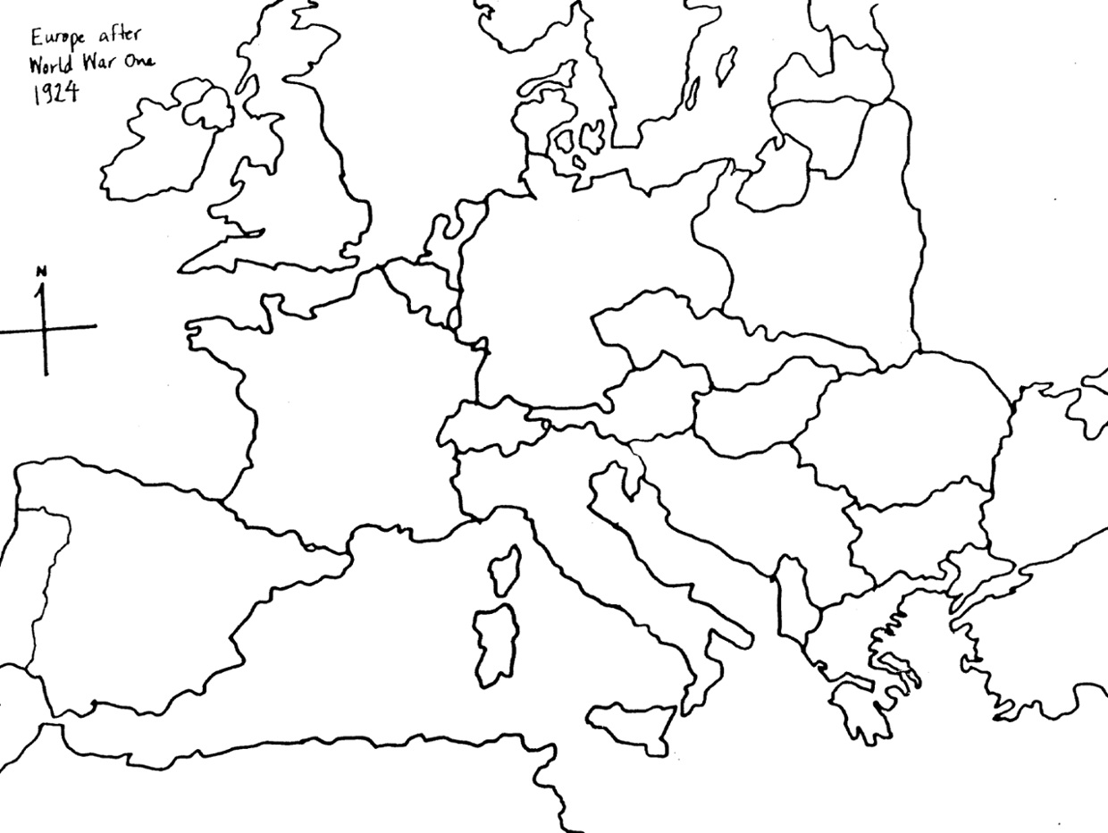](http://www.google.com/url?sa=i&rct=j&q=&esrc=s&source=images&cd=&cad=rja&uact=8&ved=0ahUKEwiftLywmZ_QAhUl5YMKHafcAwAQjRwIBw&url=http://www.thinglink.com/scene/280668162230321154&bvm=bv.138169073,d.amc&psig=AFQjCNHDVKubOe8L0cFrbXreTeVSxASh9Q&ust=1478901841539810)