**Units of Measurement:**

* **SI Units**
  + SI – System Internationale d’Unites
  + All units of measurement are based on unchanging STANDARDS
  + Uses metric prefixes (to convert from one prefix to another just move the decimal point but MUST be the same base unit!!)
    1. Length – meter (m)
    2. Mass – kilogram (kg)
       - Mass is a measure of the amount of matter in a substance
    3. Temperature – Kelvin (K)
       - Kelvin scale is an absolute scale (lowest possible temperature is absolute zero which is 0 K or -273.15oC)
       - Celsius scale is based on freezing and boiling points of water being 0oC and 100oC
       - Fahrenheit scale based on freezing and boiling points of water being 32oF and 212oF
       - **K = C + 273.15**
       - **C = 5/9 (F – 32)**
       - **F = 9/5 C + 32**
  + Derived SI Units (combining other units together)
    1. Volume
       - Volume—the amount of space that an object occupies\
       - Volume of cube = length x width x height
       - **V = L x W x H**

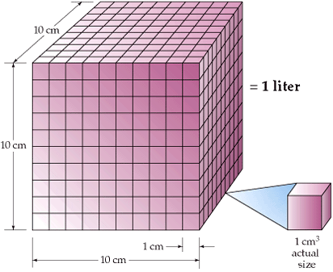

* + 1. Density
       - Density is the ratio of an object’s mass to it’s volume
       - **D = M / V**
       - Because substances usually change their volume with changes in temperature, density is temperature dependent

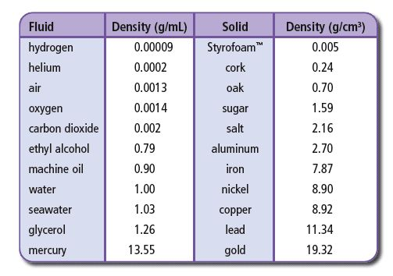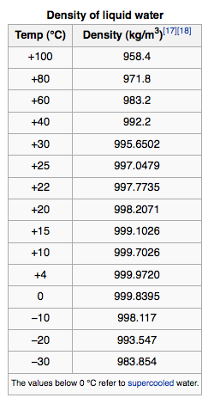

**- Uncertainty in Measurements:**

* In science some numbers are EXACT (exactly 12 eggs in 1 dozen or 1000 g in 1 kg)
* Other measured numbers are INEXACT (based on the limitations of the measuring instrument)
* Uncertainty ALWAYS exists in measured values
  + Accuracy – how close your measured value is to the real value
  + Precision – how close YOUR repeated measurements of something are to each other

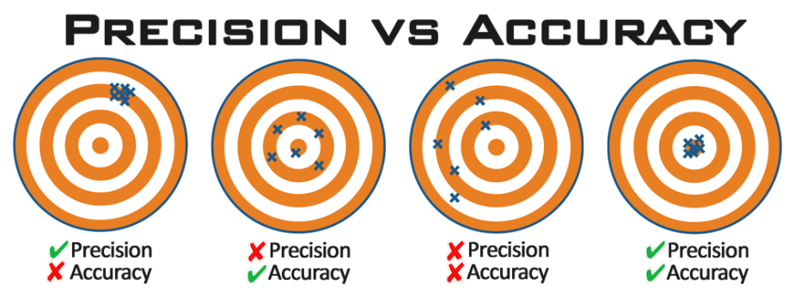

* **Significant Figures**
  + Significant figures – the number of digits that are known for certain in a measurement PLUS one more digit that is estimated or rounded
  + Uncertainty is measured in the last digit reported (as a ± but is frequently just dropped in the reported measurement) (i.e. 2.2405 ± 0.0001)
  + **RULES FOR SIG FIGS:**
    1. **All nonzero digits are significant**
    2. **Zeros between 2 nonzero #s are significant**
    3. **Zeros at the beginning of a number are not significant**
    4. **Zeros at the end of a number and AFTER the decimal point are significant**
    5. **Zeros in a number that ends in zero but has no decimal point are not significant**
    6. **There are UNLIMITED significant digits in an EXACT equality**
    7. **ALL digits in the coefficient of scientific notation are significant**
  + **Atlantic Pacific Rule:**

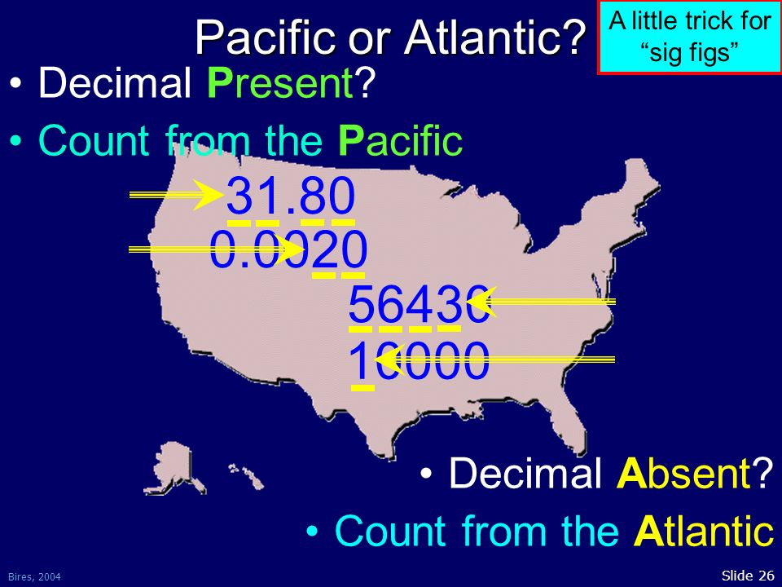

***NEVER START COUNTING WITH ZERO!!!!!***

* **Significant Figures in Calculations**
  + Rules for Rounding Off Sig Figs:
    - Looking at the LEFTMOST digit to be dropped (immediately to the RIGHT of the place you are rounding off) when rounding
    - If that leftmost digit is LESS THAN 5 then the preceding number is UNCHANGED
    - If that leftmost digit is MORE THAN 5 then the preceding digit is INCREASED (round up)
    - If that leftmost digit is 5 followed by other NONZERO numbers anywhere after it then round up
    - If that leftmost number is EXACTLY 5 then use the EVEN/ODD rule (even numbers stay the same, odd numbers round up!)
  + When multiplying or dividing numbers, round off the answer to the LEAST # of significant digits from any of the numbers used for the calculation
  + When adding or subtracting then round the answer to the leftmost uncertain COLUMN (PLACE)
  + When doing a series of calculations in order to eliminate accumulated rounding errors you should ONLY round off your FINAL ANSWER – Carry all other numbers until the very end and then round off based on the rules

**- Dimensional Analysis:**

* used as a means to convert from one unit to another based on equalities between units
* a CONVERSION FACTOR is used (fraction or ratio whose numerator and denominator are the SAME QUANTITY expressed in DIFFERENT UNITS)

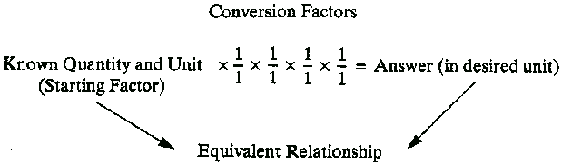

* conversion factors (12 eggs / 1 doz or 1 doz / 12 eggs) are used so the units you are converting will CANCEL and you convert to the units you want
* may have to use several conversion factors before you reach the units that you need in your answer
* the units MUST be identical in order to cancel (if you have to square or cube the units then you have to square or cube the whole conversion factor!!)