**Organic Chemistry – Stereochemistry NOTES**

**- Stereochemistry:**

- stereoisomers—molecules with the SAME FORMULA and connectivity but

a DIFFERENT ARRANGEMENT of their atoms in space

- enantiomer—stereoisomers that are NONSUPERIMPOSABLE mirror

images of each other

- chiral—any object that cannot be directly superimposed on its mirror

image

- chiral molecules LACK SYMMETRY (does not have an internal plane of

symmetry!)

- achiral—a compound whose mirror image is identical to itself

- CHIRAL molecules have at least ONE C that has 4 DIFFERENT groups

bonded to it

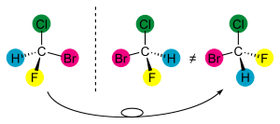

Image courtesy of <http://en.wikibooks.org/wiki/Organic_Chemistry/Alkanes/Stereoisomers>

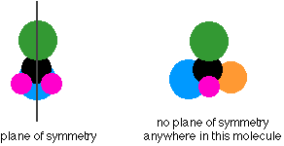

Image courtesy of <http://www.chemguide.co.uk/basicorg/isomerism/optical.html>

- **Naming Stereoisomers:**

- enantiomers of the same molecule have different properties when they

interact with light or react with other chiral molecules

- the **R/S nomenclature system** is used to name chiral molecules

- “R” stands for the Latin word *rectus* (“right”) and S for the Latin word

*sinister* (“left”)

- substituent groups around the stereocenter are ranked and their

orientation around the stereocenter is determined

- rank the substituent groups 1 (HIGHEST) 🡪 4 (LOWEST) using the same

rules as the E/Z isomerism system

- Draw the molecule (or use a model) so that the LOWEST priority group is

pointing AWAY from you

- Draw an arrow from 1 🡪 2 🡪 3 in the molecule

- If the arrow points CLOCKWISE, the configuration is **“R”**—if the

configuration points COUNTERCLOCKWISE then the configuration is **“S”**

- name the molecule by putting the letter before the name of the molecule

in parentheses

1 = OH

2 = COOH

3 = CH3

4 = H

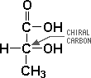 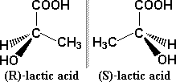

Images courtesy of <http://www.dave-cushman.net/bee/lactic.html>

*- Ex. Determine the configuration of the stereocenter shown in the molecule below.*

http://www.mhhe.com/physsci/chemistry/carey5e/nomenclature/stereochem/stereo1-2.gif

- **Diastereomers:**

- diastereomers—stereoisomers that are NOT mirror images of one

another

- diastereomers are common when molecules have more than one

stereocenter

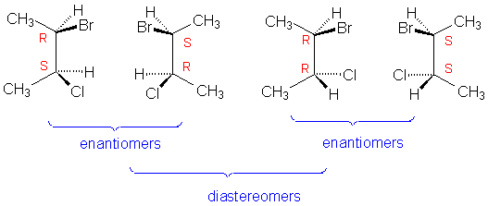

Image courtesy of <http://chemistry.umeche.maine.edu/CHY251/Exams/F09p2q7.html>

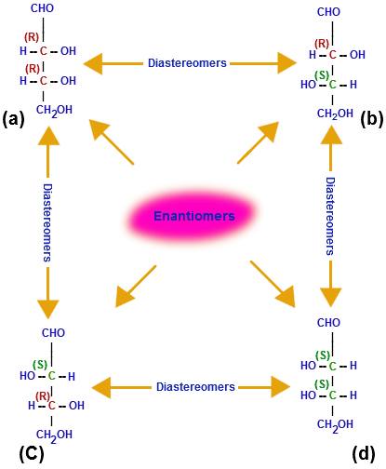

Image courtesy of <http://chemistry.tutorvista.com/organic-chemistry/isomers.html>

- enantiomers have opposite configurations at ALL stereocenters

- diastereomers have opposite configurations at SOME stereocenters

- **Meso compounds:**

- meso compound—has 2 or more stereocenters but ALSO contains a plane

of symmetry

- meso compounds are ACHIRAL molecules with stereocenters

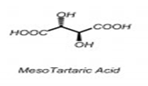

Image courtesy of <http://www.aceorganicchem.com/blog/2013/05/17/meso-compounds-in-organic-chemistry-surprisingly-not-chiral/>

**- Alkene Stereoisomerism:**

- Alkenes CANNOT have enantiomers of each other but they CAN have

diastereomers due to cis-trans isomerism

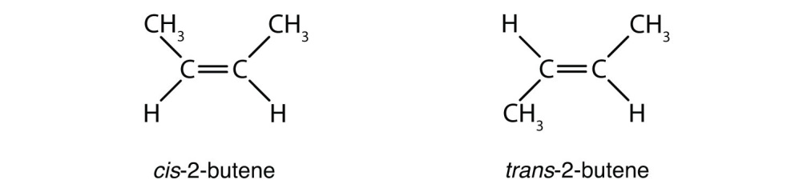

Image courtesy of <http://2012books.lardbucket.org/books/introduction-to-chemistry-general-organic-and-biological/s16-02-cis-trans-isomers-geometric-is.html>

**- Optical Activity in Chiral Compounds:**

- enantiomers are optically active (they rotate the plane of polarized light)

- light behaves as an EMR wave that radiates in all directions

- a polarizer will only allow light to pass through in ONE particular direction

- if a CHIRAL molecule is placed in FRONT of a polarizer then the light will

pass through but it will ROTATE in a particular direction

- DEXTROROTATORY—chiral compound that rotates light in the

CLOCKWISE direction and is given the symbol (+) in the prefix

- LEVOROTATORY—chiral compound that rotates light in the

COUNTERCLOCKWISE direction and is given the symbol (-) in the prefix

- (+) and (-) have NOTHING to do with R and S!!!

- achiral compounds do NOT rotate light at all

- RACEMIC MIXTURE—has an equal mix of BOTH enantiomers of a chiral

compound (the mixture is NOT optically active—does NOT rotate light!)

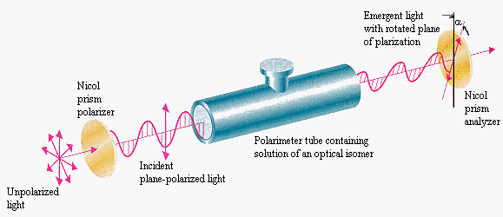

Image courtesy of <http://chemed.chem.purdue.edu/genchem/topicreview/bp/1organic/chirality.html>

- **Physical & Chemical Properties of Stereoisomers:**

- ENANTIOMERS have identical physical properties (boiling point, melting

point, density, solubility, acidity, etc.) EXCEPT the direction that they

rotate the plane of polarized light

- ENANTIOMERS have identical chemical properties when interacting with

ACHIRAL compounds

- ENANTIOMERS have different chemical properties when interacting with

other chiral compounds (IMPORTANT for Biochemistry because most

molecules in the body are CHIRAL!!)

- (S)-thalidomide works well as a treatment for morning sickness is

pregnant women but (R)-thalidomide causes terrible birth defects

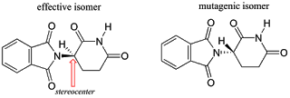

Image courtesy of <http://organici.blogspot.com/2013/10/thalidomide-good-or-bad.html>

- DIASTEREOMERS have completely different chemical and physical

properties

- RACEMIC MIXTURES are a 50:50 mixture of enantiomers and are optically

inactive

- MESO compounds are optically inactive and achiral