**Chemistry IB – Reaction Rates & Thermodynamics Notes**

- **Rates of Reaction:**

- Collision Theory:

- **rate**—measures the speed of change within a given interval of

time

- usually expressed as amount of reactant changing per unit

time

- **Collision Theory**—*atoms, ions and molecules can react to*

*form products when they collide, provided that the particles*

*have enough kinetic energy*

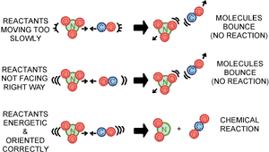

- **activation energy**—the minimum amount of energy that

particles must have in order to react

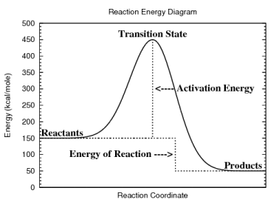

- **activated complex**—the arrangement of atoms at the peak of

the activation energy barrier

- the activated complex is sometimes also called the

**TRANSITION STATE**

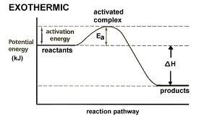 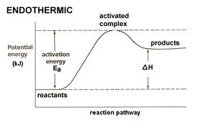

- **Factors Affecting Reaction Rate:**

1) **Temperature**—usually raising the temperature INCREASES

the rate and decreasing temperature usually DECREASES

the rate ***{NOT true for ENZYMES (biological catalysts)}***

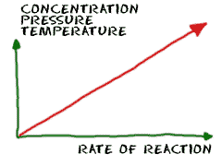 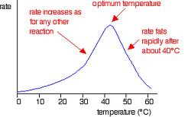

2) **Concentration**—the HIGHER the concentration (more

particles) the FASTER the reaction rate

3) **Particle Size**—the SMALLER the particles, the MORE

SURFACE AREA is available to react, so the FASTER the

reaction rate

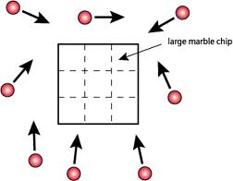 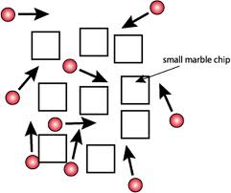

4) **Catalysts**—speeds up a reaction WITHOUT being used up

in the reaction by LOWERING the activation energy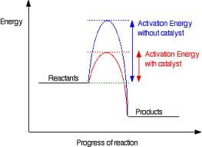

- enzymes—biological catalysts

- need specific temperatures to function properly

- inhibitor—a substance that interferes with the action

of a catalyst

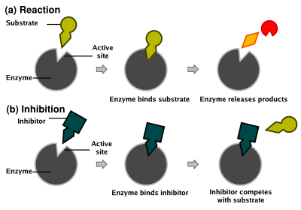

This type of inhibition is called COMPETITIVE inhibition because the inhibitor binds to the ACTIVE SITE (same as the substrate so it COMPETES for the binding site!!)

[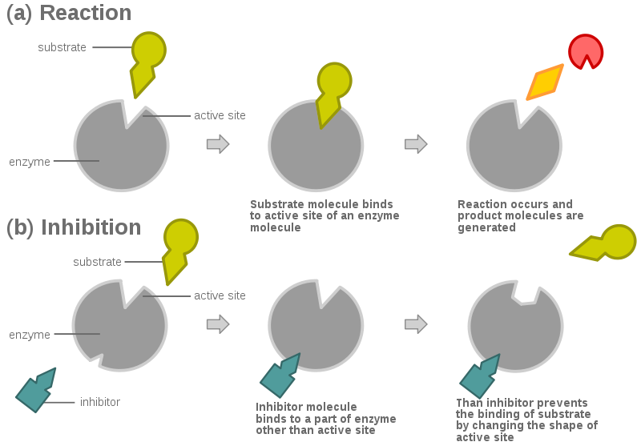](http://upload.wikimedia.org/wikipedia/commons/6/60/Allosteric_competitive_inhibition_3.svg)

This type of inhibition is called NON COMPETITIVE inhibition because the inhibitor binds to a DIFFERENT site which CHANGES the ACTIVE SITE (so the substrate CANNOT bind to the binding site!!)

- **Reversible Reactions and Equilibrium**

- Reversible Reactions:

- **reversible reaction**—occurs simultaneously in both directions

- **2 SO2(g) + O2(g) ↔ 2 SO3(g)**

- at start of reaction, proceeds in forward direction only

- as more SO3 forms, the concentration increases and it

starts speeding up in the reverse direction

- eventually the forward and reverse rates are **EQUAL** so

**CHEMICAL EQUILIBRIUM** is reached

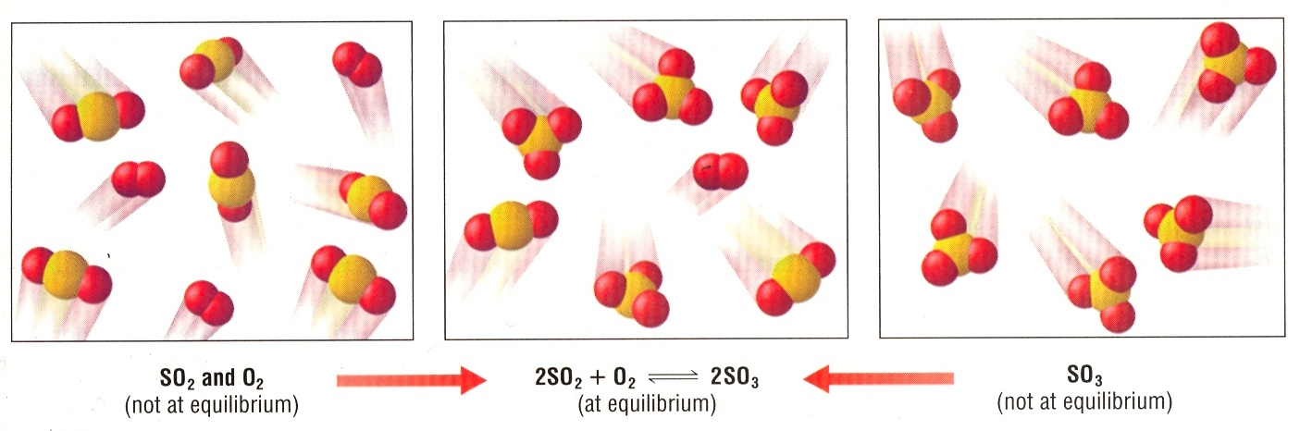

- Factors Affecting Equilibrium:

- **Le Chatelier’s principle:** *If a stress is applied to a system in*

*dynamic equilibrium, the system changes to relieve the stress*

- if equilibrium is disrupted in some way, the system will

change until a **NEW EQUILIBRIUM** is reached

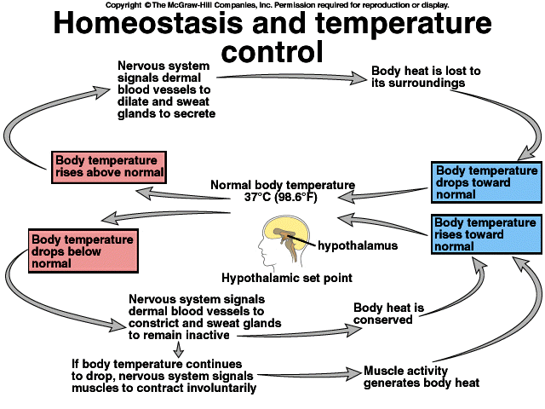

1) **Concentration**—changing the amount of any reactant or

product will affect the equilibrium

**H2CO3(aq) ↔ CO2(aq) + H2O(l)**

- add more CO2 and the reaction shifts to favor the

**REVERSE** reaction

- if you remove CO2 the reaction shifts to favor the

**FORWARD** reaction

2) **Temperature**—increasing the temperature causes the

equilibrium position to shift in the direction that absorbs

heat

**2 SO2(g) + O2(g) ↔ 2 SO3(g) + heat**

- add heat and the reaction shifts to favor the **REVERSE**

- take heat away and the reaction shifts to favor the

**FORWARD**

3) **Pressure**—changing pressure on a system ONLY affects an

equilibrium that has a UNEQUAL number of moles of

gaseous reactants and products

**N2(g) + 3 H2(g) ↔ 2 NH3(g)**

- increase pressure and the reaction shifts to favor the

**FORWARD** because the products have ***less total***

***particles***

- decrease pressure and the reaction shifts to favor the

**REVERSE** (***more particles*** to compensate for less

pressure)

- **Equilibrium Constants:**

- **Equilibrium Constant**—a ratio of the product concentrations

to the reactant concentrations at equilibrium

- ***a*A + *b*B ↔ *c*C + *d*D**

**[C]c [D]d**

**Keq = ------------**

**[A]a [B]b**

- if Keq < 1 then reactants are favored at equilibrium

- if Keq > 1 then products are favored at equilibrium

- *A liter of a gas mixture of dinitrogen tetroxide and nitrogen*

*dioxide are at equilibrium at 10oC. The mixture contains*

*0.0045 moles N2O4 and 0.030 moles NO2. Calculate the*

*equilibrium constant for this mixture of gases.*

**N2O4(g) < -- > 2 NO2(g)**

0.0045 M 0.030 M

* *A closed system initially containing 0.00100 M H2 and 0.00200 M I2 at 448oC is allowed to reach equilibrium and at equilibrium the [HI] is 0.00187 M. Calculate the value of Keq at 448oC.*

|  |  |  |  |
| --- | --- | --- | --- |
|  | **H2(g)  + I2(g) < -- > 2 HI(g)** | | |
| **I = Initial** | **0.00100 M** | **0.00200 M** | **0** |
| **C = Change** | **- x** | **- x** | **+ 2x** |
| **E = Equilibrium** | **0.00100 – x M** | **0.00200 – x M** | **0 + 2x = 2x = 0.00187M** |

**So since we know that 2x = 0.00187 🡪 x = 0.000935**

**So that means the equilibrium [H2] = 0.00100 – 0.000935 = 0.000065 M**

**And the equilibrium [I2] = 0.00200 – 0.000935 = 0.001065 M**

|  |  |  |  |
| --- | --- | --- | --- |
|  | **H2(g)  + I2(g) < -- > 2 HI(g)** | | |
| **I = Initial** | **0.00100 M** | **0.00200 M** | **0** |
| **C = Change** | **- x** | **- x** | **+ 2x** |
| **E = Equilibrium** | **0.00100 – x M = 0.000065 M** | **0.00200 – x M = 0.001065 M** | **0 + 2x = 2x = 0.00187M** |

**So …**

* *The following reversible reaction at equilibrium has a Keq of 1.67 x 10-7* *at 800*oC. *What are the concentrations at equilibrium if you react 0.0250 M H2S??*

***2 H2S(g) < -- > 2 H2(g) + S2(g)***

|  |  |  |  |
| --- | --- | --- | --- |
|  | **2 H2S(g)  < -- > 2 H2(g) + S2(g)** | | |
| **I = Initial** | **0.0250 M** | **0** | **0** |
| **C = Change** | **- 2x** | **+ 2x** | **+ x** |
| **E = Equilibrium** | **0.0250 – 2x ≈ 0.0250M** | **2x** | **x** |

***So if we plug these EQUILIBRIUM values into our formula for KEQ we will end up with an x3 term, an x2 term, an x and a constant value and that is very difficult to solve BUT since KEQ is very small in comparison to the initial [H2S] we can IGNORE THE “– X” term (even – 2x)!! and that will simplify the calculation a lot!***

- **Determining Whether A Reaction Will Occur:**

- Free Energy And Spontaneous Reactions:

- **Free Energy**—the energy that is available to do work

- not all energy that is available can be used efficiently

- some energy is always lost

- **Spontaneous Reactions**—reactions that naturally favor the

formation of the products at the specified conditions

- **Nonspontaneous Reactions**—do NOT favor the formation of

the products at the specified conditions

- whether a reaction is spontaneous or not says ***NOTHING***

about the rate of the reaction!!

- **Entropy:**

- **entropy (S)**—the amount of disorder in a system

- both enthalpy (H) and entropy (S) determine whether or not a

reaction is spontaneous

- processes tend to favor higher entropy (more disorder)

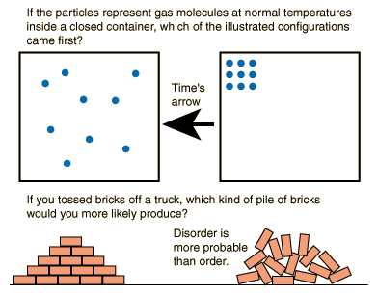

- Factors that increase Entropy:

1) solid 🡪 liquid 🡪 gas

2) dividing into smaller parts

3) total number of product particles > reactants

4) temperature increases

- you can’t measure entropy directly, only the CHANGE in

entropy (ΔS)

- **Heat, Entropy and Free Energy:**

- **Gibbs Free Energy Change (ΔG)**—the maximum amount of

energy that may be coupled to another process to do useful

work

- **ΔG = ΔH - T ΔS**

- if ΔG = (-) then the reaction is spontaneous

- if ΔG = (+) then the reaction is nonspontaneous

|  |  |  |
| --- | --- | --- |
| **Relating Enthalpy, Entropy & Free Energy** | | |
| **∆H** | **∆S** | **∆G** |
| **(-) exothermic** | **(+) INCREASE disorder** | **ALWAYS (-) (spontaneous)** |
| **(-) exothermic** | **(-) DECREASE disorder** | **(-) at lower T** |
| **(+) endothermic** | **(+) INCREASE disorder** | **(-) at higher T** |
| **(+) endothermic** | **(-) DECREASE disorder** | **ALWAYS (+) (nonspontaneous)** |

- *Determine whether the reaction 2 Na(s) + Cl2(g) 🡪 2NaCl(s) is*

*spontaneous at the standard states.*

*This could be solved a number of ways depending on the information that is given!*

*GIVEN: ΔH: Na(s) = 0 kJ/mol Cl2(g) = 0 kJ/mol NaCl(s) = - 411.12 kJ/mol*

*ΔS: Na(s) = 51.21 J/molK Cl2(g) = 223.08 J/molK NaCl(s) = 72.11 J/molK*

And

*So if ΔH = -822.24 kJ and ΔS = -181.28 J/K then…*

*GIVEN:* *ΔG: Na(s) = 0 kJ/mol Cl2(g) = 0 kJ/mol NaCl(s) = - 384.04 kJ/mol*

- **The Progress Of Chemical Reactions:**

- Rate Laws:

- the rate of a reaction depends in part on the concentrations of

the reactants

- A 🡪 B

- rate = ΔA / Δt or:

- Rate = k [A]

- k = the specific rate constant

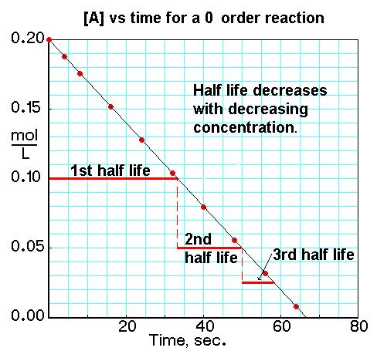

- first order reaction—the rate is directly proportional to only

ONE reactant’s concentration

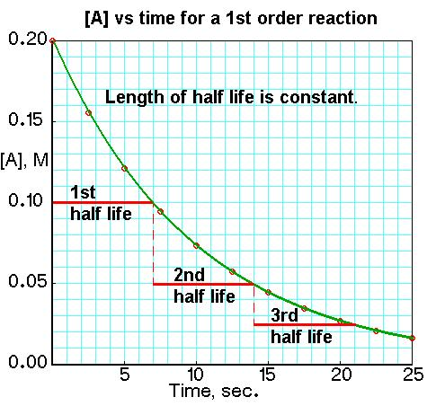

- aA + bB 🡪 cC + dD

- rate = k [A]a [B]b

- add the exponents a and b to get the overall order of a more

complex reaction (order = a + b)

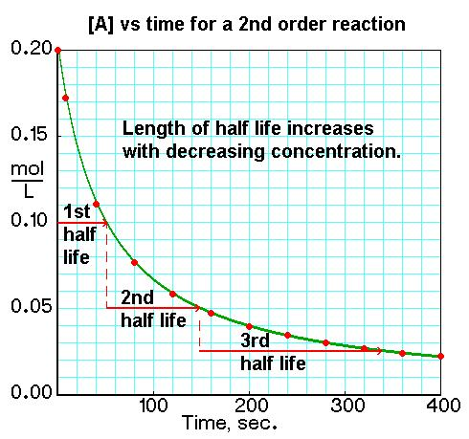

- *The rate law for the one step reaction aA 🡪 B is of the form*

*Rate = k[A]a. From the data in the following table, find the*

*kinetic order of the reaction with respect to A and the overall*

*order of the reaction*

Initial [A] (mol/L) Initial Rate (mol/L•sec)

----------------------- -----------------------------

0.050 3.0 x 10-4

0.100 1.2 x 10-3

0.200 4.8 x 10-3

*So in order to solve here, we are going to work with the RATIO of the rate laws for different trials and use algebra to solve for the exponent (a)*

*I will focus on a ratio of RATE3 and RATE2 because it is a little easier to see what is happening with the numbers.*

**So …**