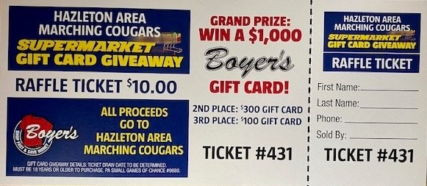

The HAHS Marching Band is selling raffle tickets till January 10th.
To help with our spring programs.

The drawing will be the 2nd Saturday in January, live on the Marching Bands Facebook page.

3 chances to win for
$10.00

Please text Tammie Bolitsky for tickets 570-401-0430, or a member of the Marching band.

