**Chemistry IA – Formulas & Nomenclature**

**- Ionic Bonding:**

- Valence electrons – the electrons in the outer energy level of an atom

- these are the electrons that are involved in bonding

- OCTET RULE – atoms will gain, lose or share electrons in order to get a

stable OCTET (8) of electrons in their outer energy level (H wants to get 2)

- easiest to focus on the valence electrons by using LEWIS DOT

STRUCTURES (electron dot structures) that only show the valence

electrons

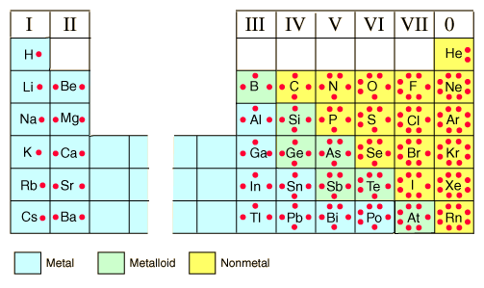

- The Formation of Cations:

- Cation – a positively charged ion

- cations are formed when METALS LOSE electrons

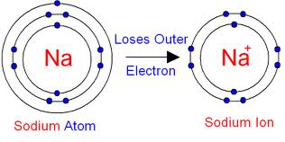

- The Formation of Anions:

- Anion – a negatively charged ion

- anions form when NONMETALS GAIN electrons

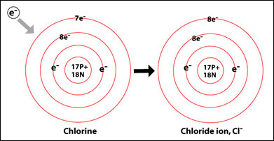

- The Formation of Ionic Bonds:

- ionic bond – results from the TRANSFER of electrons from a METAL

to a NONMETAL

- BOTH the metal and nonmetal gain a stable octet

- STRONG attraction between fully charged ions hold it together in

an IONIC BOND

- although the ionic compound that results is made up of (+) and (-)

ions, overall the charge of the compound is ZERO (NEUTRAL!!)

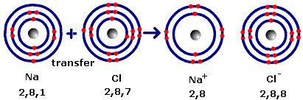

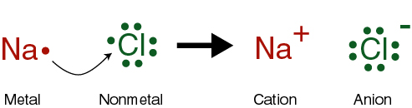

- Chemical Formulas:

- chemical formula—shows the type and number of atoms in the

SMALLEST WHOLE NUMBER ratio that makes up a substance

**-** also called an EMPIRICAL formula

- used for IONIC compounds

- in a crystal structure of NaCl, there are 6 Na+ surrounding

every Cl- AND there are 6 Cl- surrounding every Na+ (so a 1:1

ratio)

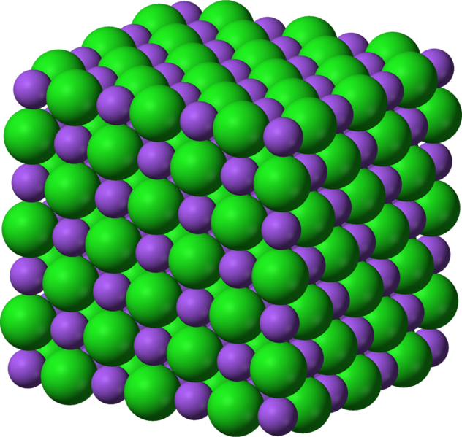

- **Some Laws involving Compounds:**

**- Law of Definite Composition:** in any chemical compound, the MASSES of

the elements are always in the SAME RATIO regardless of the amount or

source of the sample

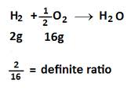

- **Law of Multiple Proportions:** whenever 2 elements combine to form

more than one compound, the different masses of one element combine

with a FIXED MASS of the other element in a ratio of small whole numbers

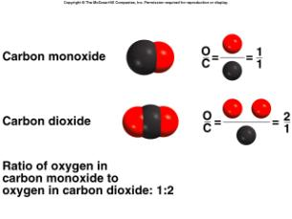

**- Naming Monatomic Ions:**

- Monatomic Ion—only ONE atom making up the ion

- charges come from the Periodic Table (based on valence electrons and

how much they will gain or lose)

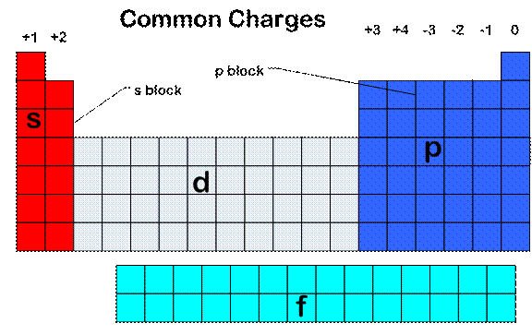

- metal ions named exactly like the elements with the word “ION” at the

end

Na – sodium Na+ -- sodium ion

Mg – magnesium Mg2+ -- magnesium ion

- nonmetal ions use the ROOT name of the element + the ending “ide”

Cl – chlorine Cl- -- chloride ion

O – oxygen O2- -- oxide ion

- many transition metals have MORE THAN ONE possible charge

- use the ELEMENT NAME plus a ROMAN NUMERAL in parentheses

that indicates the charge of the ion

- Fe2+ -- iron (II) ion Fe3+ -- iron (III) ion

- Cu+ -- copper (I) ion Cu2+ -- copper (II) ion

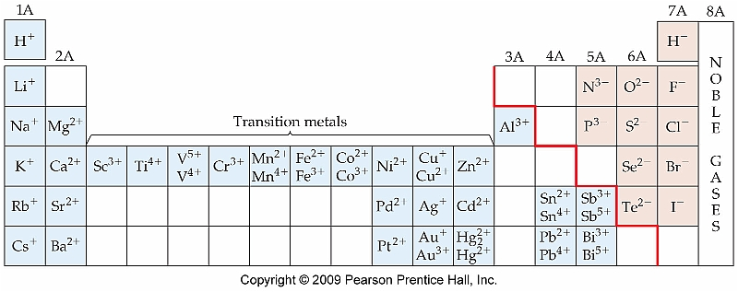

- Naming Polyatomic Ions:

- POLYATOMIC ION – a covalently bonded molecule that has an excess or

shortage of electrons and is therefore CHARGED (acts as an ion)

OH- -- hydroxide ion

CN- -- cyanide ion

NH4+ -- ammonium ion {the only one that has a POSITIVE charge}

- most contain OXYGEN bonded to another atom (named after this other

atom)

- NO2- -- nitr*ite* ion (LESS O)

- NO3- --nitr*ate* ion (MORE O)

- CO32- -- carbon*ate* ion

- HCO3- -- hydrogen carbonate or *bi*carbonate ion

- ClO- -- *hypo*chlor*ite* (one less than LESS O)

- ClO2- -- chlor*ite* ion (LESS O)

- ClO3- -- chlor*ate* ion (MORE O)

- ClO4- -- *per*chlor*ate* ion (one more than MORE O)

Dear students,

Most “ATE” ions have three oxygens!!

Love,

Mr. Moss

P.S. some have four oxygens!!

**- Writing Formulas for Ionic Compounds:**

- the TOTAL charge on the ionic compound MUST equal ZERO!!!

- STEP 1: Write the formula for the ions side by side – POSITIVE FIRST,

NEGATIVE LAST

Al3+ SO42-

- STEP 2: CRISS-CROSS the absolute value of the charges to become the

SUBSCRIPTS of the opposite ions

Al3+2 SO42-3

- STEP 3: Write the formula for the final compound.

- simplify the subscripts to the SMALLEST whole number ratio

- if you have MORE THAN ONE of a polyatomic ion, then put the

polyatomic ion in parentheses and place the subscript outside of

the end of the parentheses

Al2(SO4)3

- STEP 4: Make sure the algebraic sum of ALL the charges is ZERO

Al : 2 x 3+ = 6+

SO4 : 3 X 2- = 6-

--------------------------

0

- **Naming Ionic Compounds:**

- ionic compounds are all made up of TWO things (+ and -)

- name the (+) ion FIRST

- name the (-) ion LAST

NaCl -- sodium chloride

KOH -- potassium hydroxide

NH4Br -- ammonium bromide

- sometimes ionic compounds start with transition metals that have MORE

THAN ONE charge…. You MUST figure out what the charge of the metal

ion is in order to name the compound

- ALWAYS CHECK THE CHARGES OF ***BOTH IONS!!!!***

**FeCl3**

- there are 2 ways to figure out the charge of the iron in this

compound:

1) since the original charges were CRISS-CROSSED to become

the subscripts, bring them back up as charges (REVERSE!!)

- however, you MUST double check to see that the

subscript on the metal (Fe) matches the (-) charge on

the Cl because the formula MAY have been reduced!!!

**Fe3+(1) Cl-3**

Since Cl IS actually a 1- charge, the charge on Fe is 3+

So this compound is *iron (III) chloride*

2) since the algebraic SUM of the charges has to be ZERO, use

algebra to figure out the charge of Fe since you KNOW that

Cl must be a 1-

**Fe + 3 Cl = 0**

**Fe + 3 (-1) = 0**

**Fe – 3 = 0**

**Fe = +3**

So this compound is *iron (III) chloride*

*What is the name of this compound?*

**CuO**

**- Covalent Bonding:**

- covalent bond – formed by the SHARING of electrons between 2 atoms

that need them to obtain their stable OCTET (8)

- usually between 2 NONMETAL atoms (or a metalloid)

- H2

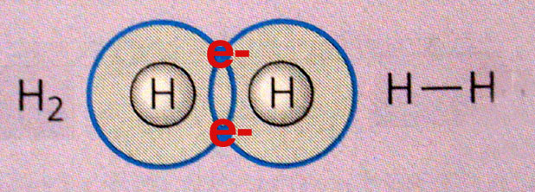

- structural formula – shows the ARRANGEMENT of atom in molecules or

polyatomic ions

- uses (—) to represent BONDED (shared) electrons

- dots represent unshared electrons

- molecular formula – shows the actual number of atoms of each element   
 in ONE MOLECULE (not necessarily the smallest whole number ratio!!)

C6H12O6 – glucose

C6H12O6 – galactose

C6H12O6 – fructose

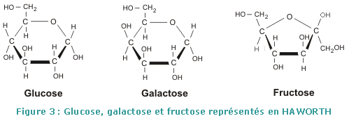

***All three molecules have the SAME molecular formula but different structural formulas!!***

- diatomic molecules – elements that exist in nature as a molecule

**H2 O2 N2 Cl2 Br2 I2 F2**

- single covalent bond – formed by sharing ONE PAIR (2) of electrons

- double covalent bond – formed by sharing TWO PAIRS (4) of electrons

- triple covalent bond – formed by sharing THREE PAIRS (6) of electrons

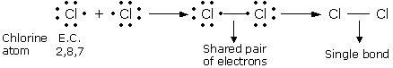

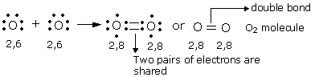

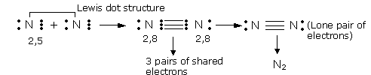

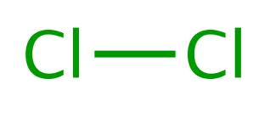 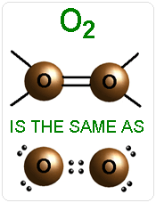 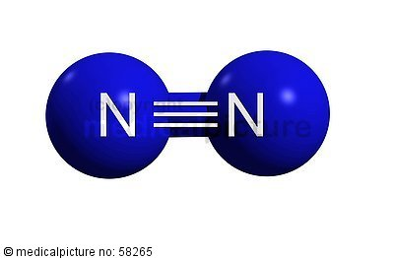

- **Naming Binary Molecular Compounds:**

- use a PREFIX to indicate the exact number of each atom in the molecule

- Prefixes:

MONO- (1) HEXA- (6)

DI- (2) HEPTA- (7)

TRI- (3) OCTA- (8)

TETRA- (4) NONA- (9)

PENTA- (5) DECA- (10)

- don’t use “MONO” to start the name of the molecule … if only one of the

first element exists in the formula (subscript = 1) then NO PREFIX to start

NI3 -- nitrogen triiodide

- if the element’s name begins with a VOWEL, then the “O” or “A” in the

prefix is dropped

CO -- carbon monoxide

- S2F8 -- disulfur octafluoride

- PBr5 – phosphorous pentabromide

- C3H6 – tricarbon hexahydride

- N2O4 -- dinitrogen pentoxide

**- Acids:**

- acid—a molecular compound that contains 1 or more H atoms

- Naming Binary acids

- contain H and one of the halogens

- HF *hydro*fluor*ic* *acid*

- HCl *hydro*chlor*ic* *acid*

- HBr *hydro*brom*ic* *acid*

- HI *hydro*iod*ic* *acid*

- Naming Oxyacids

- contain H, O, and a 3rd element

- named after the POLYATOMIC ION that forms the acid

- “-ite” ending becomes “-ous” in the acid name

- “-ate” ending becomes “-ic” in the acid name

- HNO3 nitr*ic* acid

- HNO2 nitr*ous* acid

- HC2H3O2 acet*ic* acid

- H2CO3 carbon*ic* acid

- H2SO4 sulfur*ic* acid

- H2SO3 sulfur*ous* acid

- H3PO4 phosphor*ic* acid

- Writing Formulas for Acids:

- although acids are MOLECULES (covalently bonded together) they

ionize in aqueous solution so we think of them as being ionic

- formulas are written JUST LIKE IONIC compounds are

- positive ion is ALWAYS H+

- since you will ALWAYS have a SUBSCRIPT of ONE (1) on the

negative ion (H always has 1+ charge) you will NEVER have to use

parentheses for polyatomic ions AND you will NEVER have to

reduce the formula!!!!

- *Ex. Sulfuric acid*

*- Ex. Hydrochloric acid*