**Organic Chemistry – Alkenes & Alkynes NOTES**

**- Alkenes & Alkynes:**

- Alkene—a hydrocarbon compound (contains C and H) that also contains

at least ONE C=C DOUBLE BOND

- General Formula: **CnH2n** (for any alkene with ONE C=C)

- names end in **“-ENE”**

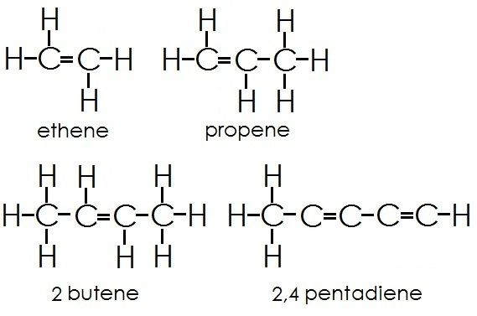

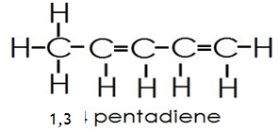

1,3

Image courtesy of <http://education-portal.com/academy/lesson/what-is-hydrocarbon-definition-formula-compounds.html#lesson>

- Alkyne-- a hydrocarbon compound (contains C and H) that also contains

at least ONE CΞC TRIPLE BOND

- General Formula: **CnH2n-2** (for any alkyne with ONE CΞC)

- names end in **“-YNE”**

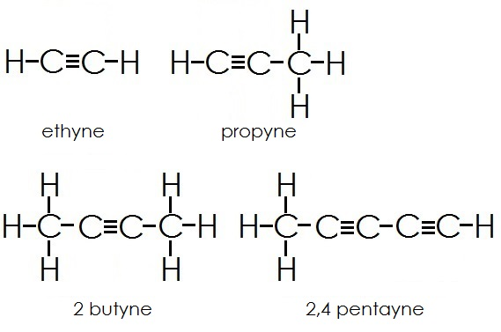

1,3 pentadiyne

Image courtesy of [http://education-portal.com/academy/lesson/what-is-hydrocarbon-definition-formula-compounds.html#lesson](http://education-portal.com/academy/lesson/what-is-hydrocarbon-definition-formula-compounds.html" \l "lesson)

**- Naming Alkenes & Alkynes:**

- to name alkenes and alkynes:

1) Find the PARENT CHAIN (LONGEST C chain containing the C=C or

CΞC). The parent name is the same as the ALKANE name but

change the ending to ***“-ene”*** or ***“-yne”***

2) NUMBER the C chain beginning at the end NEAREST the C=C or

CΞC. If the distance is the SAME in both directions then start

numbering on the side nearest to the FIRST BRANCH point

3) List the SUBSTITUENTS ALPHABETICALLY with their numbers in the

same way that alkanes are named. The C=C or CΞC is numbered

using the LOWER number C in the bond.

4) If there is MORE THAN ONE double or triple bond then ***“-diene”*** or

***“-triene”***, etc. is used

5) Cyclic cycloalkenes or cycloalkynes are named in the same way

except that the double or triple bond is always between Cs 1 & 2

in the ring structure and the numbers go in the direction to give

the LOWEST possible number to the substituent groups

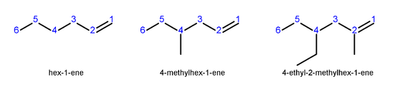

Image courtesy of <http://en.wikipedia.org/wiki/Alkene>

*- Name the following molecule according to IUPAC rules:*

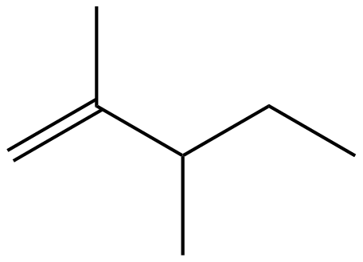

- *Draw 2-methyl-3-heptene (line drawing)*

**- cis-trans Isomerism in Alkenes:**

- *Ex. 2-butene*

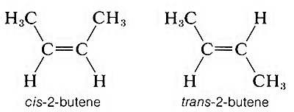

Image courtesy of <http://www.organicchemistry.com/stereoisomerism-of-organic-molecules-configurational-isomers/>

- **“CIS-“**—means the substituent groups are on the SAME SIDE of the C=C

- **“TRANS-“**—means that the substituent groups are on OPPOSITE sides of

the C=C

- don’t have to worry about cis and trans with alkynes because the

substituent groups are always 180o from the CΞC so there is NO same or

opposite side

- sometimes the **“E-/Z-“ NOTATION** is used in place of cis and trans

- they really can be used interchangeably because they are both

focusing on the same thing!

- you MUST use E/Z nomenclature when there are MORE THAN 2

substituents on the carbons of a C=C

- the ***“E-“ isomer*** is the same as TRANS!! (*E = Entegen* which is

German for OPPOSITE)

- the ***“Z-“ isomer*** is the same as CIS!! (*Z = Zusamen* which is German

for TOGETHER)

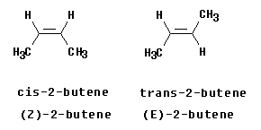

Image courtesy of <http://bbruner.org/obc/ez.htm>

- how to determine if you have an E- or Z- isomer:

1) DRAW the substituents on each side of the C=C and stretch

them out with correct 120o bond angles around the C=C so

you can see all the atoms

2) PRIORITIZE the substituents attached to each carbon of C=C

- the HIGHER ATOMIC NUMBER of the atom attached to

the C of the C=C gets HIGHER PRIORITY (if the atoms

are the same then keep working down the side chain!)

3) “Z-“ isomer has the highest priority substituents on the

SAME side of the C=C and the “E-“ isomer has the highest

priority substituents on OPPOSITE sides of the C=C

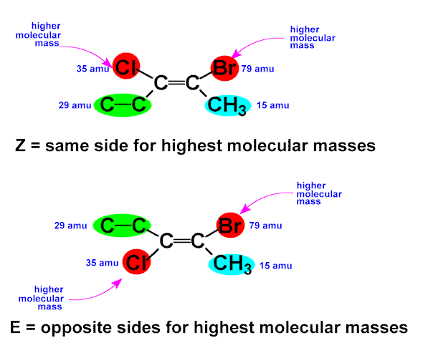  
Image courtesy of <http://chemtech.org/cn/cn2323/chapter%206a%20-%20alkenes.htm>

- *Ex. Name the following molecule according to the E/Z nomenclature.*

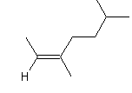

- *Ex. Draw (line drawings) E-3-methyl-2-pentene*

- **Reactions of Alkenes & Alkynes**

**-** major reaction of alkenes & alkynes is ELECTROPHILIC ADDITION

- addition reaction—something is ADDED to an alkene to make a

substituted alkane

- General Mechanism:

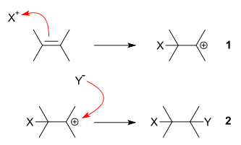

CARBOCATION

Intermediate

Image courtesy of <http://en.wikipedia.org/wiki/Electrophilic_addition>

- CARBOCATION—a carbon with a (+) charge

- first **X—Y** separates into **X+** (electrophile) and **Y-** (nucleophile)

- then **X+** takes 2e- from the alkene breaking the C=C and creates a

CARBOCATION intermediate on the opposite C that X is added to (on the

other side of the C=C)

- finally, the nucleophile **Y-** attacks the C+ and forms a bond

- so overall, X and Y are added to both sides of the C=C making a

substituted alkane as the product

- the product that is formed depends on the alkene that reacts

- *Markovnikov’s Rule: the first step in electrophilic additions results in the*

*formation of the MORE HIGHLY SUBSTITUTED carbocation intermediate!!*

- the MORE SUBSTITUTED the carbocation (the more alkyl substituents it

has) the MORE STABLE it is

- that is because carbocations can steal electrons from adjacent carbons

that have their electrons MORE than the hydrogens they are bonded to

(this is called the INDUCTIVE EFFECT)

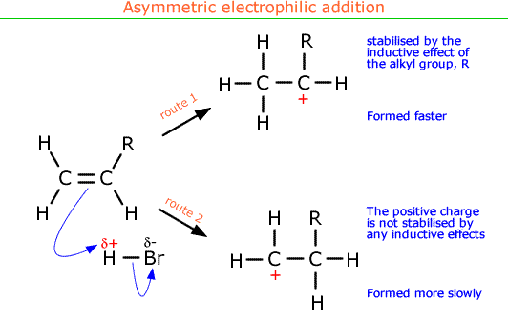

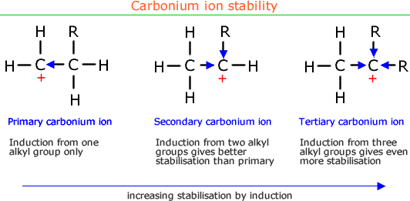

Images courtesy of <http://alevelchem.com/aqa_a_level_chemistry/unit3.2/sub3209/02.htm>

- **Hydrohalogenation Reaction:**

**- H—X** is added to an alkene according to Markovnikov’s rule

- X is Cl, Br or I

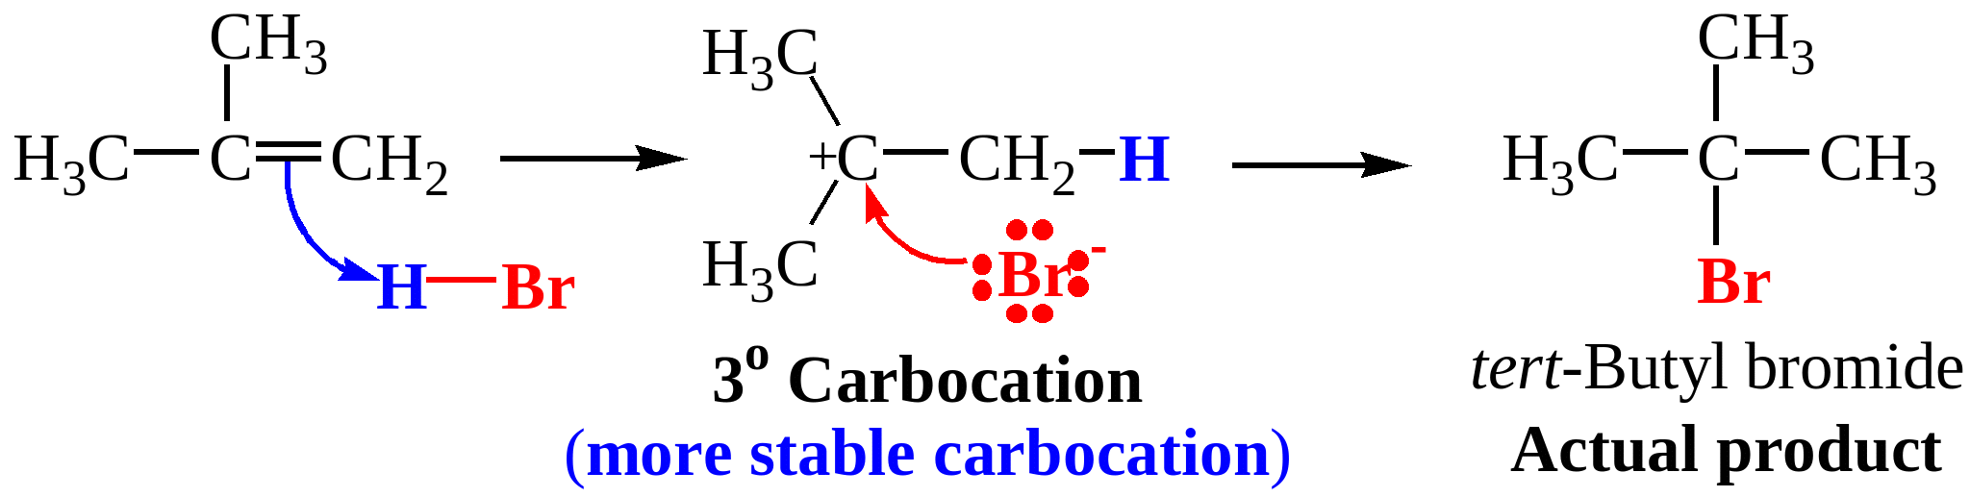

*this reaction predominates because of the 3o carbocation*

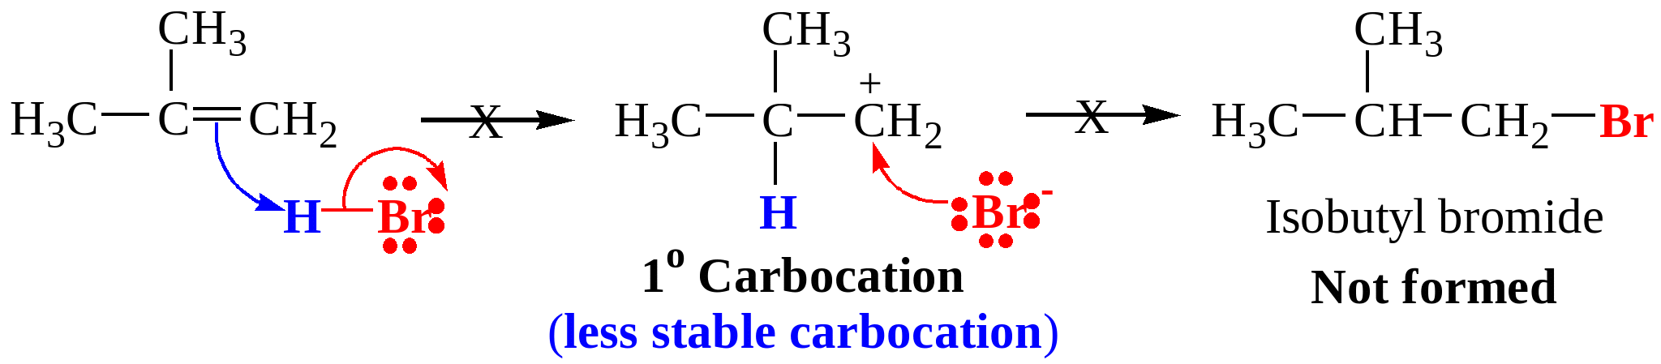

*this reaction does not occur because the 1o carbocation is much less stable!*

Images courtesy of <http://dc354.4shared.com/doc/re5AeTDq/preview.html>

- reaction takes place in 2 steps (mechanism):

1) π electrons of the C=C grabs the H of H—X and forms the

carbocation intermediate

2) the X- ion forms a bond with the (+) carbocation. Markovnikov’s

Rule forces the X- to add to the MORE SUBSTITUTED alkene

carbon

- *Ex. Write the reaction and predict the products for the reaction of HBr with*

*3-methyl-2-pentene*

**- Hydration of Alkenes:**

- water is added across the C=C of an alkene and one C bonds to the H and

the other carbon bonds to the OH

- General reaction:

>C=C< + H2O 🡪 R—OH

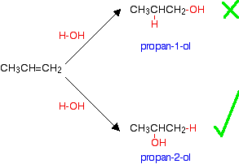

MARKOVNIKOV’S RULE

is followed!!

Image courtesy of <http://www.chemguide.co.uk/organicprops/alcohols/manufacture.html>

**MECHANISM:**

This reaction is ACID catalyzed so the C=C removes H+ from H3O+ and forms the carbocation intermediate

Then water adds to the carbocation intermediate forming an oxonium ion

Finally, H+ is removed from the OXONIUM ion intermediate forming the R—OH

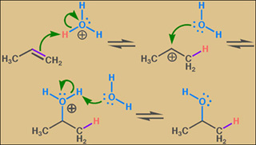

Image courtesy of <http://ocw.mit.edu/courses/chemistry/5-12-organic-chemistry-i-spring-2003/>

- *Ex. Write the reaction for and predict the product for the reaction of water in the presence of acid with 1-methyl-cyclohexene*

- **Halogenation of Alkenes:**

- adding **X2** (Cl2 or Br2) to an alkene

- produces a disubstituted alkane as a product

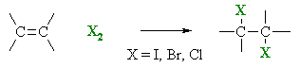

+

Image courtesy of <http://www.chem.ucalgary.ca/courses/350/Carey5th/Ch06/ch6-7.html>

MECHANISM:

First the π electrons in >C=C< bond to the first Br+ causing a cyclic BROMONIUM ion to form

Then the second Br- has to attack the C—C in the bromonium ion from the BACK SIDE (ANTI addition!!)

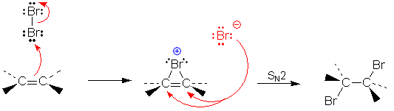



Image courtesy of <http://www.chemgapedia.de/vsengine/vlu/vsc/en/ch/12/oc/vlu_organik/alkene/halogenaddition_an_alkene.vlu.html>

- if the halogenation occurs on a cyclic alkene then the addition is always

TRANS!!

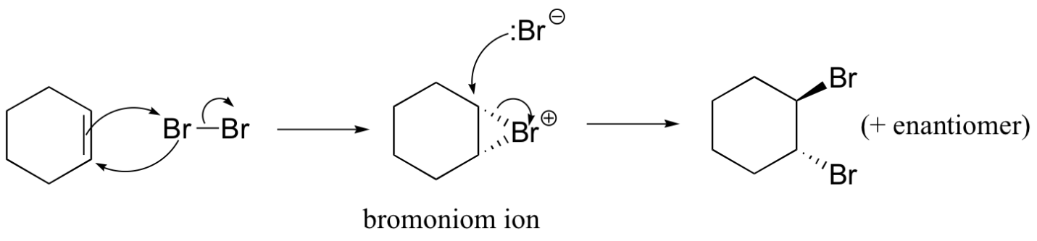

Image courtesy of <http://chemwiki.ucdavis.edu/Organic_Chemistry/Organic_Chemistry_With_a_Biological_Emphasis/Chapter_16%3A_Oxidation_and_reduction_reactions/Section_16.11%3A_Halogenation_of_organic_compounds>