**WORLD WAR II PROPAGANDA WORKSHEET**

**Directions:** *Examine the provided posters and answer the questions that follow.*

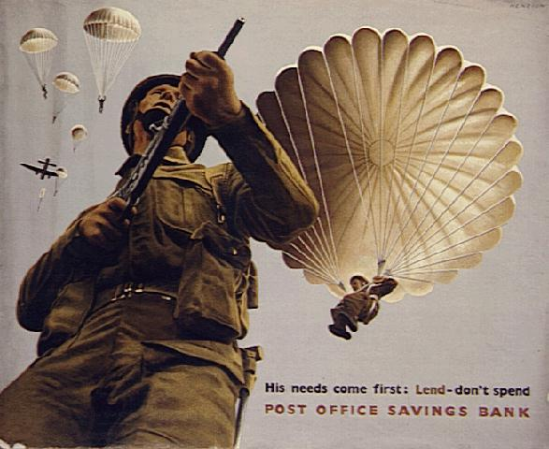

# _“His needs come first: Lend—don’t spend.” Post Office Savings Bank_

1. What do you see in this poster? Describe it in detail.
2. What is the bank telling people to do? Why should people follow the advice of the bank?
3. What do you think is the main message in this poster? Why?
   1. What do you see in this poster? Describe it in detail.

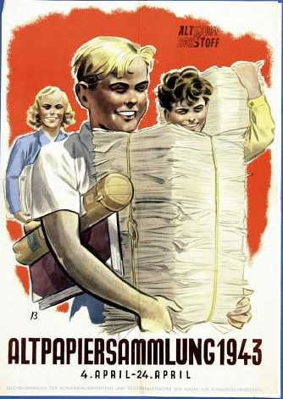

* 1. Why might it be important to collect paper? How might it help the war effort?
  2. What do you think is the main message in this poster? Why?

“Alt Papier Sammlung (Old Paper Collection) 1943, April 4-April 24”

Taking into consideration the propaganda posters you examined during class and the two provided here on this worksheet. What do the posters tell us about life during wartime? Do you think war affects enemy countries in similar ways? What role does propaganda play in war? How do you think propaganda affects people? Why?

_____________________________________________________________________________________________________________________________________________________________________________________________________________________________________________________________________________________________________________________________________________________________________________________________________________________________________________________________________________________________________________________________________________________________________________________________________________________________________________________________________________________________________________________________________________________________________________________________________________________________________________________________________________