**Aqueous Solutions**

**- Properties of Water:**

- Water – H2O

- one O and 2 H atoms connected by COVALENT bonds

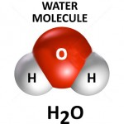

- exists as a liquid at STP

- water has a LOW vapor pressure (does not evaporate easily)

- pure water is odorless and tasteless

- since O is more EN than H, the electrons spend more time with O than H

- O is δ- and H is δ+

- bent shape geometry (AB2E2)

- POLAR molecule (because of its shape)

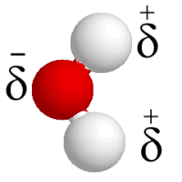

- water undergoes extensive HYDROGEN BONDING (H of one molecule

bonds to the lone pair of electrons on the O of another molecule) (HIGH

ATTRACTION between 2 water molecules!!)

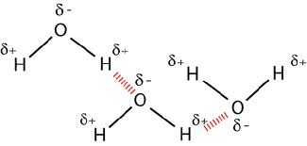

- high surface tension – surface of a LIQUID resists an external force

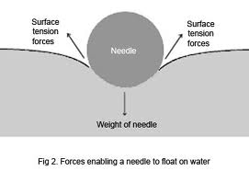 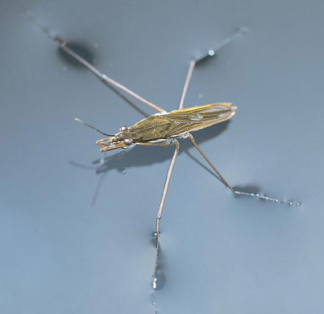

- COHESION – molecules of water “stick” together

- ADHESION – molecules of water “stick” to container walls

- capillary action – water has a tendency to move up a narrow tube

AGAINST the force of gravity

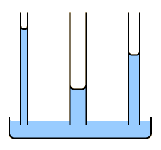 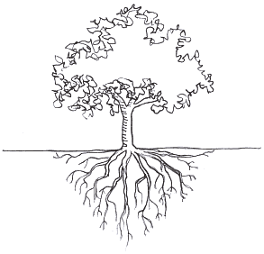

- water is a very good SOLVENT for most polar and ionic substances

(hydrophilic = water LOVING)

- water does NOT dissolve oil based substances (hydrophobic = water

FEARING)

- PURE water does NOT conduct electricity very well (poor conductor)

(but with ions, minerals or other things dissolved in it, it DOES conduct

electricity)

- water has the 2nd HIGHEST specific heat (ammonia is the 1st) (this means

it HOLDS LOTS of heat before changing its temperature)

- water has a maximum density of 1.00 g/cm3 at 3.98oC making it one of

the ONLY substances whose solid form FLOATS in its own liquid

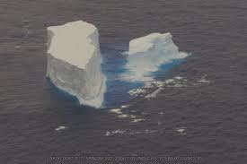

**- Solutions:**

- solution—a homogeneous mixture of a substance dissolved in another

substance

- solute—substance that is dissolved

- solvent—the dissolving medium (what the solute is dissolved in)

- aqueous solution—a solution where the solvent is water

- water is known as the “universal solvent”

- that does NOT mean that water dissolves everything!!

- hydrophilic (ionic and polar) will dissolve in water (MOSTLY!!)

- hydrophobic (nonpolar) will NOT dissolve

- solvation—the process by which solute particles become surrounded by

solvent molecules as they go into solution

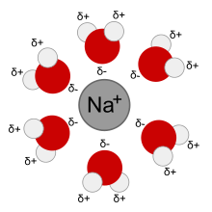 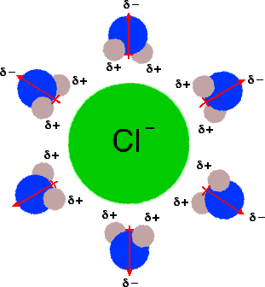

- NaCl dissolves in water because the interaction between water and

the dissociated ions in solution is MORE STABLE and LOWER

ENERGY than when NaCl is bonded together as a compound

- solubility—the amount of solute that will dissolve in a particular amount

of solvent

[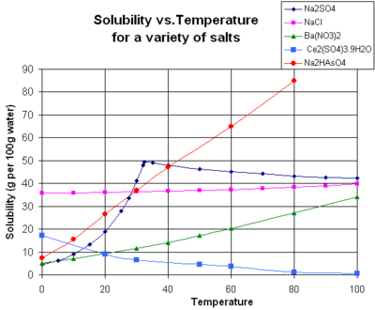](http://en.wikipedia.org/wiki/File:SolubilityVsTemperature.png)

- soluble—indicates that a SOLID substance will dissolve in another

substance (usually a liquid like water)

- insoluble—indicates that a SOLID substance will NOT dissolve

- technically it is not “insoluble”…a small amount actually

DOES dissolve but it is so small of an amount it is considered

to be “insoluble”

- miscible—indicates that a LIQUID will dissolve in another liquid

- immiscible—indicates that a LIQUID will NOT dissolve in another

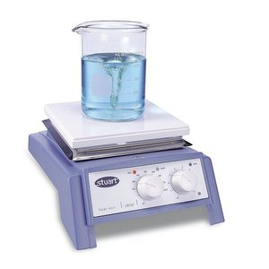 liquid

**- Factors Affecting Solution Formation:**

1) particle size – smaller particles

tend to dissolve faster 2) heat (temperature)

3) stirring/agitation

4) “like dissolves like”

- **Factors Affecting Solubility:**

1) as temperature INCREASES, the solubility of a SOLID in a liquid increases

2) as temperature INCREASES, the solubility of a GAS in a liquid decreases

3) as pressure INCREASES, the solubility of a GAS in a liquid increases

- Henry’s Law: *the solubility of a gas in a liquid at a given*

*temperature is DIRECTLY proportional to the PRESSURE of the gas*

*above the liquid*

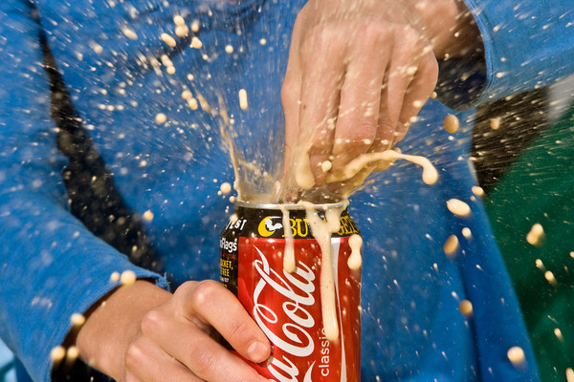

- **Types of Solutions:**

**-** concentrated—has a LARGE amount of solute particles in a given amount

of solvent

- dilute—has a SMALL amount of solute particles in a given amount of

solvent

- unsaturated—contains LESS THAN the maximum amount of solute in a

particular amount of solvent

- saturated—contains the maximum amount of solute in a particular

amount of solvent

- supersaturated—contains MORE THAN the maximum amount of solute in

a particular amount of solvent

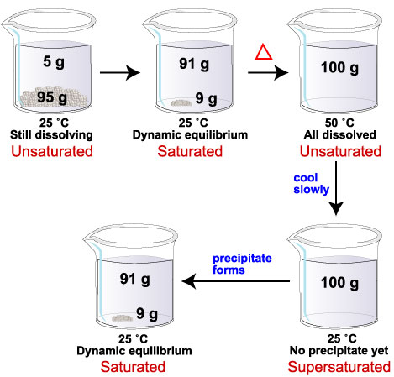

- **Solution Concentration:**

- concentration—how much solute is dissolved in a particular amount of

solvent or solution

1) Percent by Volume – the grams of solute per mL of solution (expressed

as a percentage)

**grams SOLUTE**

**Percent by Vol. = ---------------------------------- x 100**

**mL SOLUTION**

- *How many grams of glucose would be needed to make 500mL of a*

*20% solution?*

*- What is the percent by volume of 25 g NaCl dissolved in 700 mL*

*total solution?*

2) Molarity (M)—moles of solute per LITER of solution

**Moles SOLUTE**

**MOLARITY (M) = -----------------------------**

**Liters SOLUTION**

- *What is the molarity of a solution of 2.00 moles glucose in 5.00 L of*

*total solution?*

*- How many grams of NaCl are needed to make 2.50 L of a 0.100 M*

*NaCl solution?*

3) Molality (m)—moles of solute per kg of solvent

**Moles SOLUTE**

**Molality (m) = ---------------------------**

**kg SOLVENT**

- *How many grams of KI must be dissolved in 500.0 g of water to*

*make a 0.45 m KI solution?*

- **Dilutions:**

- to dilute a solution (make it LESS concentrated) you need to INCREASE

the amount of SOLVENT!!! (“water down”)

- since the TOTAL number of MOLES of solute still remains the same in

solution (only the amount of solvent and total solution changes) then the

following is true:

Volume in LITERS x MOLARITY (mol/L) = moles solute

Since the moles of solute before and after are the same:

**V1C1 = V2C2**

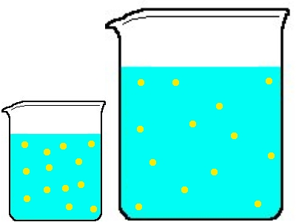

- *How much of a 2.00 M MgSO4 stock solution would be needed to*

*make 100.0 mL of 0.400 M MgSO4?*

- serial dilutions—dilutions are done in a SERIES (one after the other) in

order to make a very small concentration that would not be convenient to

make in one step

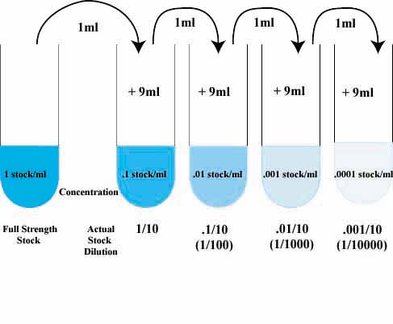

**- Colligative Properties:**

- colligative property—depends ONLY on the number of particles of solute

dissolved in a given mass of solvent (not on the identity of the solute!!)

1) Boiling Point Elevation (ΔTb)

- the boiling point of a solution is always HIGHER than the boiling

point of a pure solvent

- as a solute dissolves in a solvent the particles of the solute become   
 “solvated” (surrounded by water molecules in a particular

formation) and there is an ATTRACTION from solute—solvent.

- the more the attraction is, the HARDER it is to separate the solvent

from the solute (so the boiling point INCREASES!!)

- **ΔTb = *i* Kb m**

*i* is the # of particles per molecule or formula unit of solute

C6H12O6 🡪 C6H12O6(aq) [1 particle]

NaCl 🡪 Na+(aq) + Cl-(aq) [2 particles]

CaCl2 🡪 Ca2+(aq) + 2 Cl-(aq) [3 particles]

AlCl3 🡪 Al3+(aq) + 3 Cl-(aq) [4 particles]

Kb is the molal boiling point depression constant

Kb for water is +0.51 Co·kg H2O/mol solute

m is the molality (mol solute/kg H2O)

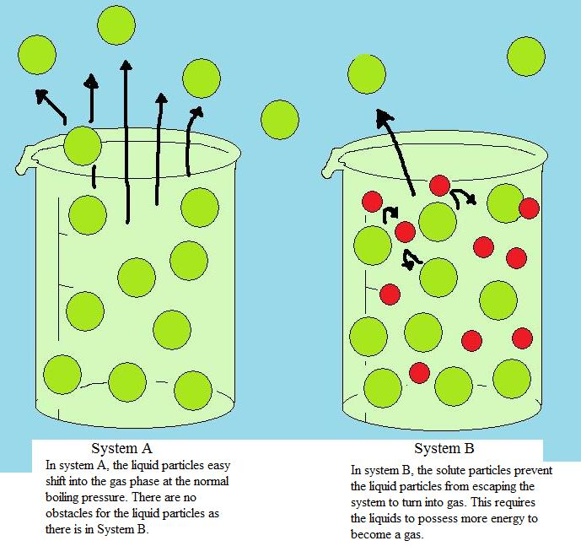

2) Freezing Point Depression (ΔTf)

- the freezing point of a solution is always LOWER than the freezing

point of a pure solvent

- as a solute dissolves in a solvent the particles of the solute become   
 “solvated” (surrounded by water molecules in a particular

formation) the solute particles take up space that is normally

occupied by water molecules forming a crystalline structure so it

makes it more difficult for that solid structure to form

- **ΔTf = *i* Kf m**

*i* is the # of particles per molecule or formula unit of solute

Kf is the molal freezing point depression constant

Kf for water is -1.86 Co·kg H2O/mol solute

m is the molality (mol solute/kg H2O)

