**Chemistry IB -- Nuclear Chemistry Notes**

- **Nuclear Radiation:**

- nuclear reaction—reaction in which the nuclei of unstable

radioactive isotopes (RADIOISOTOPES) gain stability by

undergoing changes

- changes always involve giving off HUGE amounts of energy

- nuclear reactions are different from chemical reactions:

1) not effected by temperature

2) not effected by pressure

3) not effected by catalysts

4) not effected by the type of compound that contains the

radioisotopes

5) cannot be stopped, slowed down or turned off!!

- radioactivity (named by Marie Curie)—process by which materials

give off radioactive rays

- radiation—the penetrating rays or particles emitted by a radioactive

source

- Types of Radiation:

1) **alpha particles**—helium nucleus (2 protons & 2 neutrons)

- symbol: α

- LOW penetrating power

- has a +2 charge

- radioactive element “transmutes” into an element that

is 2 atomic numbers smaller!!

- mass number decreases by 4 & atomic number

decreases by 2 (smaller mass!!!)

U 🡪 Th + He (alpha particle)

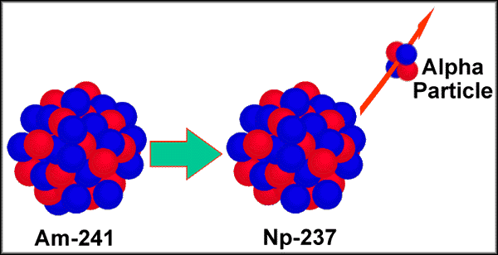

2) **Beta particles**—electrons

- symbol: β

- MEDIUM penetrating power

- has a –1 charge

- transmutation of a NEUTRON into a PROTON and an

ELECTRON (followed by the emission of the electron)

- mass number STAYS the same but the atomic number

increases (SAME MASS!!!)

C 🡪 N + e- (Beta emission)

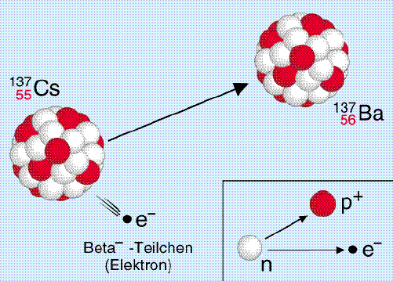

3) **Gamma rays**—high energy EMR

- symbol: γ

- VERY HIGH penetrating power

- has no charge

- does not cause a transmutation of atoms itself but very

often is accompanied by an α particle or β emission

Th 🡪 Ra + He + γ (Gamma ray)

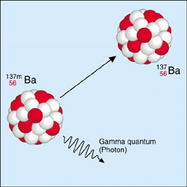

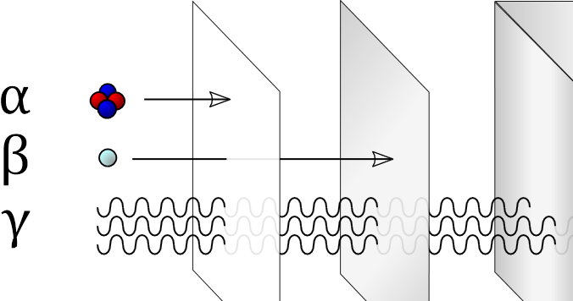

- **Half-Life:**

- **half-life**—the time required for ½ of the nuclei of a radioisotope to

decay into products

- even though the amount of radioactive material DECREASES over

time, you NEVER get to ZERO!!!

- **A = A0 x (½)t/T**

- **A** 🡪 amount of the radioactive substance remaining

- **A0** 🡪 initial amount of the radioactive substance

- **t** 🡪 time

- **T** 🡪 half-life (measured in the same units as t)

decay-graph - Radioactive Decay of Bismuth-210 (T½ = 5 days)


- **Fission and Fusion of Atomic Nuclei:**

- **nuclear fission**—the splitting of the nucleus into smaller fragments

by bombarding it with neutrons

fission reaction - The Fission Reaction of Uranium-235


- fission releases more neutrons which hit other atoms and

continue a CHAIN REACTION

- can unleash HUGE amounts of energy (1 kg U-235 fission =

energy from 20,000 tons of dynamite!!)

- examples: atomic bomb and nuclear reactors

- **nuclear fusion**—occurs when nuclei COMBINE to form a nucleus

of larger mass

- **4 H+ + 2 e- 🡪 2 He + ENERGY**

fusion reaction - Nuclear Fusion of Two Hydrogen Isotopes
 



- fusion releases more energy than fission

- takes place at temperatures above 40,000,000 oC!!

- example: the sun

- **Uses of atomic radiation:**

1) detect trace amounts of elements in samples

2) used to study chemical reactions and molecular structures

3) used to diagnose particular diseases

4) used to treat cancer

5) radioactive dating of fossils

6) used in smoke alarms

7) irradiation to sterilize food